The effects of preparation on gender differences in choice to compete

Keana Richards1, Gideon Nave1, & Coren Apicella1

1 University of Pennsylvania

Author note

Correspondence concerning this article should be addressed to Keana Richards, 3720 Walnut Street, Philadelphia PA 19104. E-mail: [keanari@sas.upenn.edu](mailto:keanari@sas.upenn.edu)

Abstract

Previous research suggests that women compete less than men, even when there are no gender differences in performance (Niederle & Vesterlund, 2011). These gender differences in competitiveness can lead to lower earnings (Niederle & Vesterlund, 2007; Reuben, Sapienza, & Zingales, 2015) and as such, may contribute to the well-established gender gap in wages (Blau & Kahn, 2017), among other important gender differences in economic and organizational advancement outcomes. One mechanism for gender differences in competitiveness is confidence, which leads women to undercompete and men to overcompete (relative to their performance level) (Niederle & Vesterlund, 2007). Since mastery has been shown to be an important driver of confidence (Gist & Mitchell, 1992; Usher & Pajares, 2008), we experimentally test whether communicating to men and women that they will have the opportunity to prepare before a competition will reduce gender differences in competitiveness through 2 studies with over 2000 participants combined. We did not find evidence that women compete more when they have the opportunity to prepare. However, we find a gender gap in preparation, where women are choosing to prepare more (Studies 1 and 2), even though they chose to compete less (Studies 1 and 2) and even after they were forced to prepare (Study 2). This gender difference in preparation aligns with participants’ beliefs about gender differences in preparation more generally (Studies 1 and 2). These findings suggest that women may prepare more than men, regardless of whether they plan on competing, with important implications for the opportunity costs of overpreparing, and implications for organizational communication about norms and what is valued.

*Keywords:* gender, choice to compete, competitiveness, economics, preparation, practice

*Word count:* X

The effects of preparation on gender differences in choice to compete

# 1 Introduction

Women have surpassed men in education outcomes, like college attendance and graduation rates (Blau & Kahn, 2017; Goldin, Katz, & Kuziemko, 2006; Stoet & Geary, 2014), but are still underrepresented in top management positions in nearly all sectors (Bertrand & Hallock, 2001) and a gender wage gap still persists (Blau & Kahn, 2017). Traditional economic variables account for some, but not all, of these disparities. Since competition is relevant to labor market outcomes, researchers began to focus on how gender affects one’s response to competition as a means of understanding persistent gender gaps in labor market outcomes (for review, see Niederle & Vesterlund, 2011). Seminal work on gender differences in competitiveness operationalized competitiveness as the choice of a tournament payment scheme that reaps potentially higher earnings but requires outperforming an opponent over a piece-rate scheme (Niederle & Vesterlund, 2007). This work found that women are less competitive than men, on average, even if they would have earned more by competing (Niederle & Vesterlund, 2007). Additionally, this laboratory measure of competitiveness predicts labor market outcomes, such as education choices (Buser, Niederle, & Oosterbeek, 2014; Zhang, 2012), entrepreneurial decisions (e.g., investment, employment; Berge, Bjorvatn, Garcia Pires, & Tungodden, 2015), and earnings (Reuben, Sapienza, & Zingales, 2015). Thus, competitive preferences may contribute to gender differences in labor market outcomes (Blau & Kahn, 2017). As such, it is important for organizations to take gender differences in competitiveness into consideration when striving to facilitate gender equality in workplace outcomes and communicating about what is required for success.

Follow-up research with nearly identical procedures has replicated the effect of gender on the choice to opt into tournaments (see Niederle & Vesterlund, 2011 for review). Notably, this effect has been replicated in diverse populations (e.g., across age groups and cultures) (Andersen, Ertac, Gneezy, List, & Maximiano, 2013; Apicella & Dreber, 2015; Buser et al., 2014; Buser, Peter, & Wolter, 2017; Dreber, Essen, & Ranehill, 2014; Mayr, Wozniak, Davidson, Kuhns, & Harbaugh, 2012; Sutter, Glätzle-Rützler, Balafoutas, & Czermak, 2016; Sutter & Rutzler, 2010) and with a diverse set of tasks (Apicella & Dreber, 2015; Bjorvatn, Falch, & Hernæs, 2016; Frick, 2011; Saccardo, Pietrasz, & Gneezy, 2018; Samek, 2019; Sutter & Glätzle-Rützler, 2015). However, there is evidence that the task used during competition affects the size of the gender gap. For instance, some research suggests that when the task is female-typed or gender-neutral, the gender gap in willingness to compete may be reduced or eliminated (Apicella & Dreber, 2015; Boschini, Dreber, Essen, Muren, & Ranehill, 2019, 2014; Dreber, Essen, & Ranehill, 2011; Dreber et al., 2014; Grosse & Riener, 2010; Günther, Ekinci, Schwieren, & Strobel, 2010; Iriberri & Rey-Biel, 2017; Shurchkov, 2012). Drawing from the psychology literature on stereotype threat (Spencer, Logel, & Davies, 2016; Spencer, Steele, & Quinn, 1999; Steele, 1997), negative stereotypes about women’s ability to perform male-typed tasks (e.g., math, mental rotation) may produce anxiety and undermine performance. As a result, women may decide not to engage in a competition because they either believe the stereotype or because the stereotype provokes enough anxiety to reduce performance (Grosse & Riener, 2010; Günther et al., 2010; Iriberri & Rey-Biel, 2017; Shurchkov, 2012).

Understanding how to address gender differences in competitiveness may be important for reducing gender inequality that persists today. When women compete less than their male counterparts, they may be missing crucial economic opportunities, as demonstrated by the evidence suggesting competitiveness is relevant to one’s economic outcomes (Buser et al., 2014; Reuben et al., 2015; Zhang, 2012). Given the importance of the gender gap in competition for women’s economic outcomes, research has explored factors underlying gender differences in competitiveness. Notably, confidence and risk attitudes have been implicated in driving the gender gap in willingness to compete (Niederle & Vesterlund, 2011; Veldhuizen, 2017), although the extent to which confidence and risk attitude account for the gender gap in willingness to compete is debated. More specifically, the seminal research in this literature suggests that confidence and risk attitude do not completely explain the gender gap in the choice to compete, since there remains a residual gap in the choice to compete after controlling for these factors (Niederle & Vesterlund, 2007). The unexplained component of the original gender effect was taken as evidence of a distinct “competitiveness” trait, separate from risk attitude and confidence (Niederle & Vesterlund, 2007, 2011). However, recent work correcting for measurement error (Gillen, Snowberg, & Yariv, 2019) and using experimental techniques to isolate the effects of the competitiveness trait (Veldhuizen, 2017) suggests that risk attitude and confidence may fully explain the gender gap in the choice to compete. Regardless of whether competitiveness is a stand-alone trait, it is clear that confidence and risk attitude can generate differences in how men and women react to competitions. Thus, interventions designed to increase risk-taking or confidence in women may help reduce the gender difference in competitiveness.

Confidence is conceptualized as the accuracy of one’s perceived performance or ability on a task (Beyer & Bowden, 1997). Since competitions, by definition, compare the performance among two or more individuals, they naturally lead to self-evaluation and comparative judgments of self with others - processes that are intimately linked to confidence.

There is ample research to suggest that women are less (over)confident on average than men across a number of domains (Bertrand, 2010; Beyer, 1990; Beyer & Bowden, 1997; Croson & Gneezy, 2009; Lundeberg, Fox, & Puncochaf, 1994; Mobius, Niederle, Niehaus, & Rosenblat, 2011; Niederle & Vesterlund, 2007, 2011). Within the literature on the gender gap in competitiveness, confidence is operationalized as the belief about one’s relative performance during a competition, where individuals who have inaccurately high ratings of their performance are deemed overconfident. If an individual does not feel as though their performance is higher than individuals they are competing against, they are unlikely to make the decision to compete for fear of missing the opportunity to earn money, even if they would otherwise outperform their opponent. Although both men and women tend to be overconfident, women are far less likely to fall into the trap of overconfidence, which leads them to compete less often than they should, given their actual ability (Niederle & Vesterlund, 2007).

Women’s relatively lower levels of confidence in their performance partly explains this gender difference (Niederle & Vesterlund, 2011), so it is important to understand factors that may affect confidence prior to the decision to compete. Confidence on a task can improve with preparation and training (Gist & Mitchell, 1992; Schunk, 1981, 1982; Usher & Pajares, 2008), since, in most cases, people are able to observe a gradual improvement in their skills over time. For instance, Lent, Brown, Gover, and Nijjer (1996) found that college students listed past performance accomplishments as the most influential factor in determining their math skill confidence. Other research directly compared the effects of mastery experiences, vicarious experiences (e.g., watching others perform a task), and a control treatment without any intervention on confidence, finding that mastery increased confidence significantly more than vicarious experiences and the control treatment (Bandura, Adams, & Beyer, 1977). Based on previous evidence of the benefits of enactive mastery through preparation and training on confidence, providing women with an adequate opportunity to prepare before a task may alleviate the gender gap in choice to compete.

Another variable that has been identified as a possible explanation for gender differences in competitiveness is risk attitude, typically construed as the preference for a certain gain over a gamble, even if the gamble has an equal or greater monetary expectation (Kahneman & Tversky, 1982). Payment based on the outcomes of a competition are inherently riskier than non-competitive payment schemes (e.g., guaranteed payment per unit of output) because in most cases, there is uncertainty surrounding one’s relative performance (Niederle & Vesterlund, 2011). Several studies across diverse settings have documented a gender difference in risk attitudes, where women tend to be more risk-averse than men on average (Apicella et al., 2017a; Bertrand, 2010; Croson & Gneezy, 2009). Because competitions are riskier and women tend to be more risk-averse, women may be more likely to compete when they know they can prepare. Preparing may increase one’s perceived likelihood of winning, and in turn, reduce the perceived risk of entering a competition.

Notably, both knowing about an opportunity to prepare before competing and the actual act of preparing may encourage high-ability women to enter competitions more often. In knowing one can prepare beforehand, one may assume that they can resolve any discrepancies between their current ability and their desired ability level for competition by preparing. This knowledge, in and of itself, may be sufficient to reduce gender differences in competitiveness, regardless of whether women actually take advantage of this opportunity. Additionally, the act of preparation may be uniquely motivating, since preparation allows an individual to observe an improvement in their performance over time. As such, women may choose to compete more after preparing (i.e., practicing and/or studying).

Here, we examined the role of preparation on the gender differences in willingness to compete through two experiments. In the first experiment, we tested whether simply knowing that there will be an opportunity to prepare before performing a task affects the gender gap in willingness to compete. That is, we manipulated participants’ knowledge of whether they had unlimited time to prepare before they made their decision to compete. We anticipated that participants with this information would be more inclined to compete compared to participants without this information. Thus, we expected an interaction between gender and condition on the choice to compete, along with a main effect of condition.

In the second experiment, we examined how actual preparation influences the decision to compete. That is, we manipulated whether participants were required to prepare before making this decision. Again, we expected that women in the preparation condition would be especially inclined to compete.

Across both studies, we also measured participants’ lay beliefs about potential differences in decision to prepare and compete by monetarily incentivizing them to correctly predict which gender would prepare and compete more. The research design, hypotheses, measures and analyses were preregistered (<https://osf.io/q39a5/>) unless otherwise stated and all analyses were conducted in R statistical software (version 4.0.3).

# 2 Study 1

## 2.1 Methods

We recruited workers on Amazon Mechanical Turk for Study 1, and those who opted into the study had to pass several screening questions. Specifically, participants included in the paid portion of the study had to (i) identify their nationality as American and live in the United States, (ii) identify as male or female, and (iii) be using a computer (rather than a phone or tablet). If they did not meet these criteria, they did not proceed to the paid portion of the study. Additionally, upon reviewing the data, we had reason to suspect that some participants completed the study more than once. Specifically, some participants had the same IP address, MTurk ID, and were of the same gender. When entries matched on all three identifiers, we included only the first entry and excluded all subsequent entries. The final sample consisted of 1056 participants (53.60% women), with an average age of 37.74 (*SD* = 13.19) years. 54 participants (53.70% women) dropped out of the study before finishing and we use their data when available.

Participants were told they would be completing a multiplication task where they would be able to choose how they would be paid for their performance. The task involved solving problems from multiplication tables 1-12 as quickly as possible within a two-minute period. They were provided an example of a question with the correct response and had to answer three practice problems correctly to proceed, as a test of their comprehension. After completing the comprehension questions, participants were randomly assigned to either a “knowledge of preparation” condition or a control condition. Participants in the “knowledge of preparation” condition were presented the following text:

“There is an option to practice/study before completing the multiplication task that is available to all participants. If you take this opportunity to practice/study, we will provide you with materials that may help boost your performance in the multiplication task. You will have unlimited time to practice/study before completing the task. You can stop practicing/studying at any point.”

Participants assigned to the control condition simply proceeded without seeing this text. Then, all participants learned about the two possible payment schemes (either piece-rate or tournament) that they would have the option to choose from and had to correctly answer questions testing their comprehension of the payment schemes.

Under the piece-rate scheme participants were told that they would be paid $.10 for every problem answered correctly. Under the tournament scheme, participants were told that they would be paid $.20 for every problem they answered correctly, but only if they answered more questions correctly than a randomly assigned competitor. Participants in the experimental condition were reminded that they had the option to prepare before completing the task. The order of presentation of the tournament and piece-rate payment options was randomized for participants.

After choosing a payment scheme, participants in both conditions were given an opportunity to prepare before the multiplication task. If they chose to prepare, participants were presented with each multiplication table, 1 through 12, in sequential order. Each multiplication table provided products of numbers up to 12. Thus, participants could use the table to study. Additionally, participants were asked if they wanted to complete practice problems. If they said yes, participants were asked to solve all multiples in that table and could only proceed to the next table if they answered all the questions correctly.

Once they completed all practice questions for a given times table, they were shown the multiplication table again and were asked if they would like to continue solving problems from that table or move onto the next multiplication table. This process was repeated for each multiplication table. Thus, we had two measures of preparation behavior: the decision to practice and the total number of times participants completed each multiplication table. The decision to practice measure conceptually captures a participants’ baseline willingness to prepare, before they know what the preparation will involve. Thereafter, the total number of preparation rounds reflects participants’ willingness to repeatedly prepare.

Following the preparation portion of the study, participants moved on to the paid portion of the study. They were required to solve as many problems as possible in two minutes. After completion, participants were told how many problems they answered correctly and completed a series of incentivized follow-up questions, including confidence and perceptions of gender differences. For these measures, participants were told one of these questions would be selected for a possible bonus payment, and if they answered the selected question correctly, they would earn a bonus of $.10. For the measure of confidence, participants were asked to correctly predict their relative performance compared to all other participants completing the task by indicating the decile of their score. Notably, the item was phrased so participants did not need to understand the word “decile,” but were asked instead: “If my performance is compared to that of all participants that completed the task, I think my score was…” with the options for responses ranging from “Better than all other participants” to “Better than none of the other participants” with 10% increments in between (e.g., “Better than 50% of participants”). Participants were also asked to correctly predict which gender 1) correctly solved more problems 2) spent more time practicing before completing the multiplication task, and 3) chose the tournament payment option more.

Finally, participants completed a measure of risk aversion, where they answered if they generally are willing to take risks or try to avoid taking risks (Dohmen & Falk, 2011) on a 10 point scale with 0 meaning participants are “Not at all willing to take risks” and 10 indicating participants are “Very willing to take risks.” To determine whether participants used additional tools to improve their performance on the task, we also asked participants about their use of calculators and perceptions of calculator use on the multiplication task. Neither of these measures was incentivized.

## 2.2 Results

An equal number of participants were assigned to both conditions (control= 50%). Of the males who completed the study, 49.90% were assigned to the control condition. Of the females who completed the study, 50.09% were assigned to the control condition.

A minority of participants (15.41%) chose to compete, contrary to previous data in this literature (Niederle & Vesterlund, 2007). Despite the small proportion of participants who chose to compete, we still replicate the gender gap in the choice to compete, where a greater share of men (19.59%) compared to women (10.78%) chose to compete. A logistic regression revealed that this gender difference in the choice to compete is significant, $b=-0.73$, 95% CI $[-1.23$, $-0.24]$, $z=-2.90$, $p=.004$. Contrary to our predictions, we do not find evidence of a significant interaction between gender and condition on the decision to compete, $b=0.06$, 95% CI $[-0.63$, $0.76]$, $z=0.18$, $p=.861$ (see Figure 1), suggesting that women in the knowledge of preparation condition were not uniquely more inclined to compete.

As hypothesized, women were 75.47% more likely to take advantage of the opportunity to practice relative to men, $b=0.56$, 95% CI $[0.31$, $0.82]$, $z=4.37$, $p<.001$, while controlling for the decision to compete (see Figure 2). As an exploratory analysis, we tested whether gender and the choice to compete interact to predict the choice to prepare, but did not find evidence for an interaction, $b=0.12$, 95% CI $[-0.60$, $0.86]$, $z=0.33$, $p=.740$.

In further support of gender differences in preparation, women completed 68.59% more rounds of preparation relative to men, $b=0.56$, 95% CI $[0.31$, $0.82]$, $z=4.37$, $p<.001$ (see Figure 3). Thus, we have evidence that women prepare more both 1) before they know what the preparation entails and 2) after they have had the chance to experience the preparation. One can imagine that these would be driven by distinct psychological mechanisms, where 1) captures whether a person generally takes advantage of any opportunity to prepare, regardless of what it involves, while 2) measures a person’s willingness to persist in their preparation, even after exerting effort previously during preparation. The fact that we find gender differences across two different forms of willingness to prepare suggests that the findings are robust. This gender difference aligned with participants’ predictions about gender differences in preparation, where participants expected women, relative to men, to spend more time preparing for the multiplication task, $χ^{2}(1,n=1056)=15.67$, $p<.001$ (see Figure 4), and in general, $χ^{2}(1,n=1056)=447.11$, $p<.001$ (see Figure 7). One possible explanation for participants’ predictions is that they expected men to outperform women on the task, which would lead women to compensate by preparing more. However, participants did not expect any gender differences in performance on the task, $χ^{2}(1,n=1056)=1.02$, $p=.313$ (see Figure 5). Additionally, participants accurately predicted that women were less likely to choose to compete, $χ^{2}(1,n=1056)=716.24$, $p<.001$ (see Figure 6), suggesting that they did not believe women prepare more because they were more likely to compete.

# 3 Study 2

## 3.1 Methods

Participants were recruited on Amazon Mechanical Turk using the same screening criteria as Study 1. Also, if participants had an identical IP address, MTurkID, and gender, we excluded their second response. The final sample consisted of 1076 participants (50.56% women), with an average age of 38.57 (*SD* = 12.52) years. 62 participants (51.61% women) dropped out of the study before finishing.

As in Study 1, participants included in the study were told they would be completing a two-minute multiplication task (identical to the one used in Study 1) and would be able to choose a payment scheme for their performance. The instructions and payment per question were identical to Study 1. After being told about the rules for the multiplication task and passing the same comprehension questions used in Study 1, participants were assigned to either a preparation condition, where they were told they would complete several rounds of preparation before completing the multiplication task, or a control condition, where they were told they would complete several rounds of a counting task before continuing. Participants were randomly assigned to each condition. The participants in the preparation condition completed 12 rounds (one round per multiplication table), with 6 problems per round. The problems for each round were selected at random. Participants in the control condition were asked to complete 5 questions where they counted the number of zeros in a matrix of zeros and ones. After a 30-second break following completion of their respective tasks, all participants chose a payment scheme for the multiplication task, where the order of presentation was counterbalanced. That is, half of participants saw the tournament scheme presented as the first option and half saw the piece-rate payment scheme presented first.

After choosing a payment scheme, participants in both conditions had the option to spend (extra) time preparing for the multiplication task. Again, we had two measures of preparation behavior: the decision to practice and the total number of times participants completed the multiplication table. If they chose to prepare, participants were given two minutes to complete a randomly selected set of problems from all 12 multiplication tables. Once they finished the first two-minute preparation round, participants could opt into 4 more rounds of preparation, each two minutes long, before they moved on to the paid portion of the study.

Then, participants completed the paid multiplication task for two minutes. We included many of the same follow-up questions as in Study 1, including risk aversion, confidence, and perceptions of gender differences in preparation, competitiveness, and performance. Participants were incentivized to answer the questions about their confidence and perceptions of gender differences correctly, and were paid at the same rate as Study 1. We also asked participants if they wished they had more time to prepare for the multiplication task and included measures of their fatigue, field-specific ability beliefs, and interest in the multiplication task all on 1 (Strongly disagree) to 7 (Strongly agree) scales. For the fatigue scale, participants rated how fatigued and mentally exhausted they felt (Milyavskaya, Galla, Inzlicht, & Duckworth, 2018). Participants indicated the degree to which they “enjoyed completing the multiplication task” for the interest scale (Milyavskaya et al., 2018). Finally, to measure field-specific ability beliefs, we asked participants how much they perceived success in math depends on ability versus effort through six questions (e.g., “If you want to succeed in math, hard work alone just won’t cut it; you need to have an innate gift or talent”) (Meyer, Cimpian, & Leslie, 2015).

## 3.2 Results

An equal number of participants were assigned to both conditions (control= 50%). Of the males who completed the study, 50% were assigned to the control condition and of the females who completed the study, 50% were assigned to the control condition.

We replicated the effect of gender on the choice to compete: 19.36% of men chose to compete compared to 13.60% of women. However, we do not find evidence of a significant effect of condition on the choice to compete among women, *z* = -1.00, *p* = 0.16 (see Figure 8), contrary to our hypotheses.

Despite no evidence for the effect of condition on the choice to compete among women, we replicate the effects found in Study 1, where women were significantly more likely to prepare for the task, even after being forced to prepare in the preparation condition (see Figure 12). Women were 18.62% more likely to take advantage of the opportunity to prepare relative to men $b=0.11$, 95% CI $[-0.39$, $0.62]$, $z=0.45$, $p=.653$, while controlling for the decision to compete (see Figure 12). Again, we find that these results align with participants’ expectations, where they were significantly more likely to expect women to choose to prepare in general, $χ^{2}(1,n=1076)=511.06$, $p<.001$ (see Figure 11), despite expecting men to choose to compete more often, $χ^{2}(1,n=1076)=578.07$, $p<.001$ (see Figure 10) and expecting no gender differences in performance on the task, $χ^{2}(1,n=1076)=0.61$, $p=.434$ (see Figure 9).

# 4 Discussion

Previous Through two experiments, we explored whether the opportunity to prepare affects gender differences in competitiveness and whether there are gender differences in willingness to prepare. Most notably, we discovered and then replicated a sizable gender difference in the willingness to prepare for a multiplication task, even though women chose to compete less and even after all participants were required to prepare.

Although previous findings within educational contexts are suggestive of gender differences in willingness to prepare (e.g., greater motivation to master schoolwork and engage in effortful learning strategies) (Kenney-Benson, Pomerantz, Ryan, & Patrick, 2006), our studies are the first to demonstrate a gender difference in preparation among adults who must explicitly opt into preparation. This effect is especially noteworthy since we are drawing from a participant pool (MTurk) where participants could be earning money for their participation through a nearly limitless supply of other studies, so any possible opportunity costs of choosing to spend extra time preparing are more palpable than in other contexts.

The observed gender difference in the willingness to prepare may be driven by women’s greater desire (relative to men) to reduce uncertainty around their future performance (given their greater average risk aversion) and/or increase their perceived ability (given their lower average confidence).

Alternatively, women may intrinsically value practicing more than men. There is a small literature suggesting that women are more likely than men to value dedication and mastery (Kenney-Benson et al.,

We also found that neither the knowledge of the opportunity to prepare nor the act of preparation itself affected participants’ willingness to compete, which was surprising, given the previous literature suggesting that mastery is one of the most important determinants of confidence in tasks (for review, see Gist & Mitchell, 1992; Usher & Pajares, 2008). Since confidence and risk attitude were measured after providing the additional option to prepare, we cannot identify whether these factors drove the null effect of condition. It is possible that the opportunity to prepare may have made participants more aware of the discrepancy between their current ability and their desired ability threshold for preparation. This increased awareness of the discrepancy may have affected participants’ confidence and/or risk attitude, in turn negating any benefits of the opportunity to prepare on the decision to compete. We intend to explore this possibility in a future study. Finally, we showed that participants accurately predicted the observed gender differences in behavior, suggesting that they observe these behaviors directly in their own lives and/or have learned about stereotypes surrounding these behaviors.

In both cases, participants’ accuracy in predicting the gender differences in competitiveness and preparation would suggest that these are not isolated findings, but in fact are representative of gender differences in other contexts, such as organizations. Since the choice to compete and prepare have the potential to affect employees’ success within organizations, our findings suggest that organizational decisions and communication should account for these gender differences to reduce persistent gender gaps in labor market outcomes.

## 4.1 Implications of opportunity costs of overpreparing before competitions

Competitions are increasingly prevalent in the global labor market (Lavy, 2004; Lemieux, MacLeod, & Parent, 2009) and the winners of competitions are disproportionately rewarded (Frank & Cook, 2010). Understanding individual differences in response to competitive situations may help address economic disparities across groups, like persistent gender differences in labor market outcomes (Altonji & Blank, 1999; Blau & Kahn, 2017). For instance, one step to improve gender equality within organizations is to take these gender differences into account when making decisions on how to organize reward structures and communicate these structures to employees, and to reward cooperation and other forms of work on par with competition.

Much of the research on gender differences in competitiveness is focused on designing interventions to increase women’s competitiveness, with less attention paid to potential downstream consequences of these interventions. Yet, understanding how women and men respond to competitions may also be crucial for organizations across contexts to address gender disparities in labor market outcomes. If competitions exacerbate gender differences in the amount of effort exerted (e.g., preparing or studying) before performance, this may affect women’s labor output, career advancement, the ability to achieve a satisfying work-life balance, and even the decision to enter or stay in competitive environments. Additionally, there are opportunity costs for expending more effort than necessary on only one task or skill, especially when an individual’s overall performance is evaluated based on their success across many domains. These effects are especially relevant to professional development in STEM fields, where gender disparities are arguably driven by gender differences in confidence (Cheryan, Ziegler, Montoya, & Jiang, 2017), increasing the likelihood women will overprepare before competition.

Relatedly, if women *expect* that they will prepare more in competitive environments, this may, in turn, impact whether they even enter competitive environments. In fact, there is evidence that the way a job is advertised affects women’s willingness to apply (Flory, Leibbrandt, & List, 2010; Gaucher, Friesen, & Kay, 2011). If a job is described as “competitive” or the payment scheme is described as a competition, women find the jobs less appealing and are less willing to apply, demonstrating the power of organizational communication on gender differences in labor market outcomes. While our work suggests that merely giving women more time to prepare does not make them more willing to compete, anticipated effort could still influence labor market outcomes by affecting women’s decisions to enter certain fields or compete for promotions, for instance. In our studies, we use relatively unimportant tasks that are unlikely to greatly impact one’s earnings. Yet, we still find a striking gender difference in preparation, suggesting that our study likely *underestimates* this gender difference. For instance, we would expect greater gender differences in preparation for tasks with higher stakes, where the outcomes are important for one’s career and economic prospects. In this way, our study is providing a conservative test of the gender differences in effort and preparation in the real world.

## 4.2 Future research

There are a number of avenues for future research in this area. First, we would like to test the robustness of gender differences in preparation outside of online and laboratory settings. Do these findings replicate in organizations? Exploring the gender difference in preparation cross-culturally would also shed light on the universality of the finding and help to identify cultural, ecological and social factors that exacerbate it.

A second important extension of the work would be to examine how organizational communications about, and resulting anticipated preparation or workload influences women’s decisions to enter competitive environments. While we did not find that giving women time to prepare makes them more likely to compete, it is still possible that women know that they will end up preparing more in competitive situations and thus, select out of them. As mentioned earlier, there are opportunity costs to overpreparing.

A third extension of the current work would be to examine whether women are overpreparing. Does preparation negatively impact women? Does it help women? To determine whether men or women are preparing more (or less) than needed, future research should test whether gender and time chosen to prepare interact to affect a participants’ probability of winning a competition (see Niederle & Vesterlund, 2007). Another follow-up study could manipulate whether there is a monetary cost for preparing to explore whether gender differences in the choice to prepare persist despite a clear cost, and whether this leads to gender differences in earnings within the study.

It would also be interesting to explore whether norms, and organizational communication of norms, about gender affect decisions to compete. Norms are important drivers of human behavior (Schultz, Nolan, Cialdini, Goldstein, & Griskevicius, 2018), so it is entirely plausible that the decision to compete and prepare might be fueled in part by what most women or men are doing, or perceptions of gender differences in these behaviors, and how visible this information is within an organization. Although there is some work exploring how gender norms affect actual behavior (Akerlof & Kranton, 2000; Babcock et al., 2012; Bertrand et al., 2015; Bowles et al., 2007; Smith & Huntoon, 2014; Toosi et al., 2019), our evidence of participants’ lay beliefs about gender differences suggests that this is an important avenue for future research. Additionally, our findings cannot speak to whether the decision to prepare directly improved participants’ performance. Future research should manipulate whether participants have the opportunity to prepare without providing the option for additional practice thereafter to explore the benefits of preparing on performance, which may negate any opportunity costs of preparing.

While we build off an extensive and laudable literature on gender differences in competitiveness, we have unearthed a gender difference in preparation. As this is a new area of research, there are many promising and exciting avenues for future exploration, all of which have the potential to inform governmental and organizational policies that ultimately mitigate gender disparities in the labor market.

# 5 Figures

## 5.1 Study 1

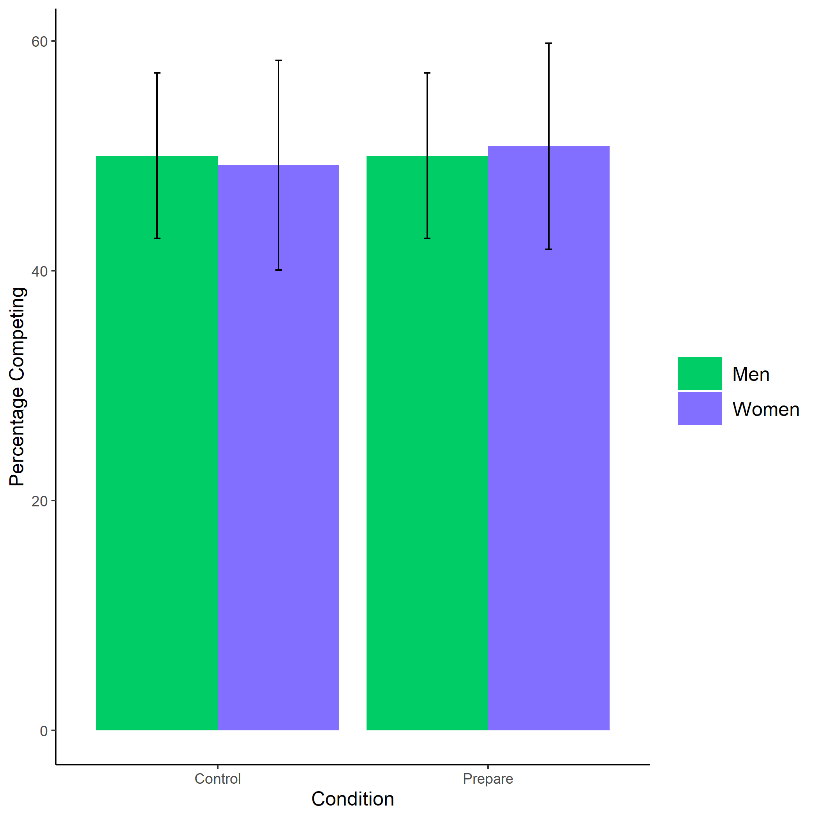

*Figure* *1.*  Proportion of male and female participants who chose to compete by condition. We do not find evidence for the hypothesized interaction between gender and condition on the choice to compete, nor do we see a main effect of condition on the choice to compete. Error bars represent standard errors.

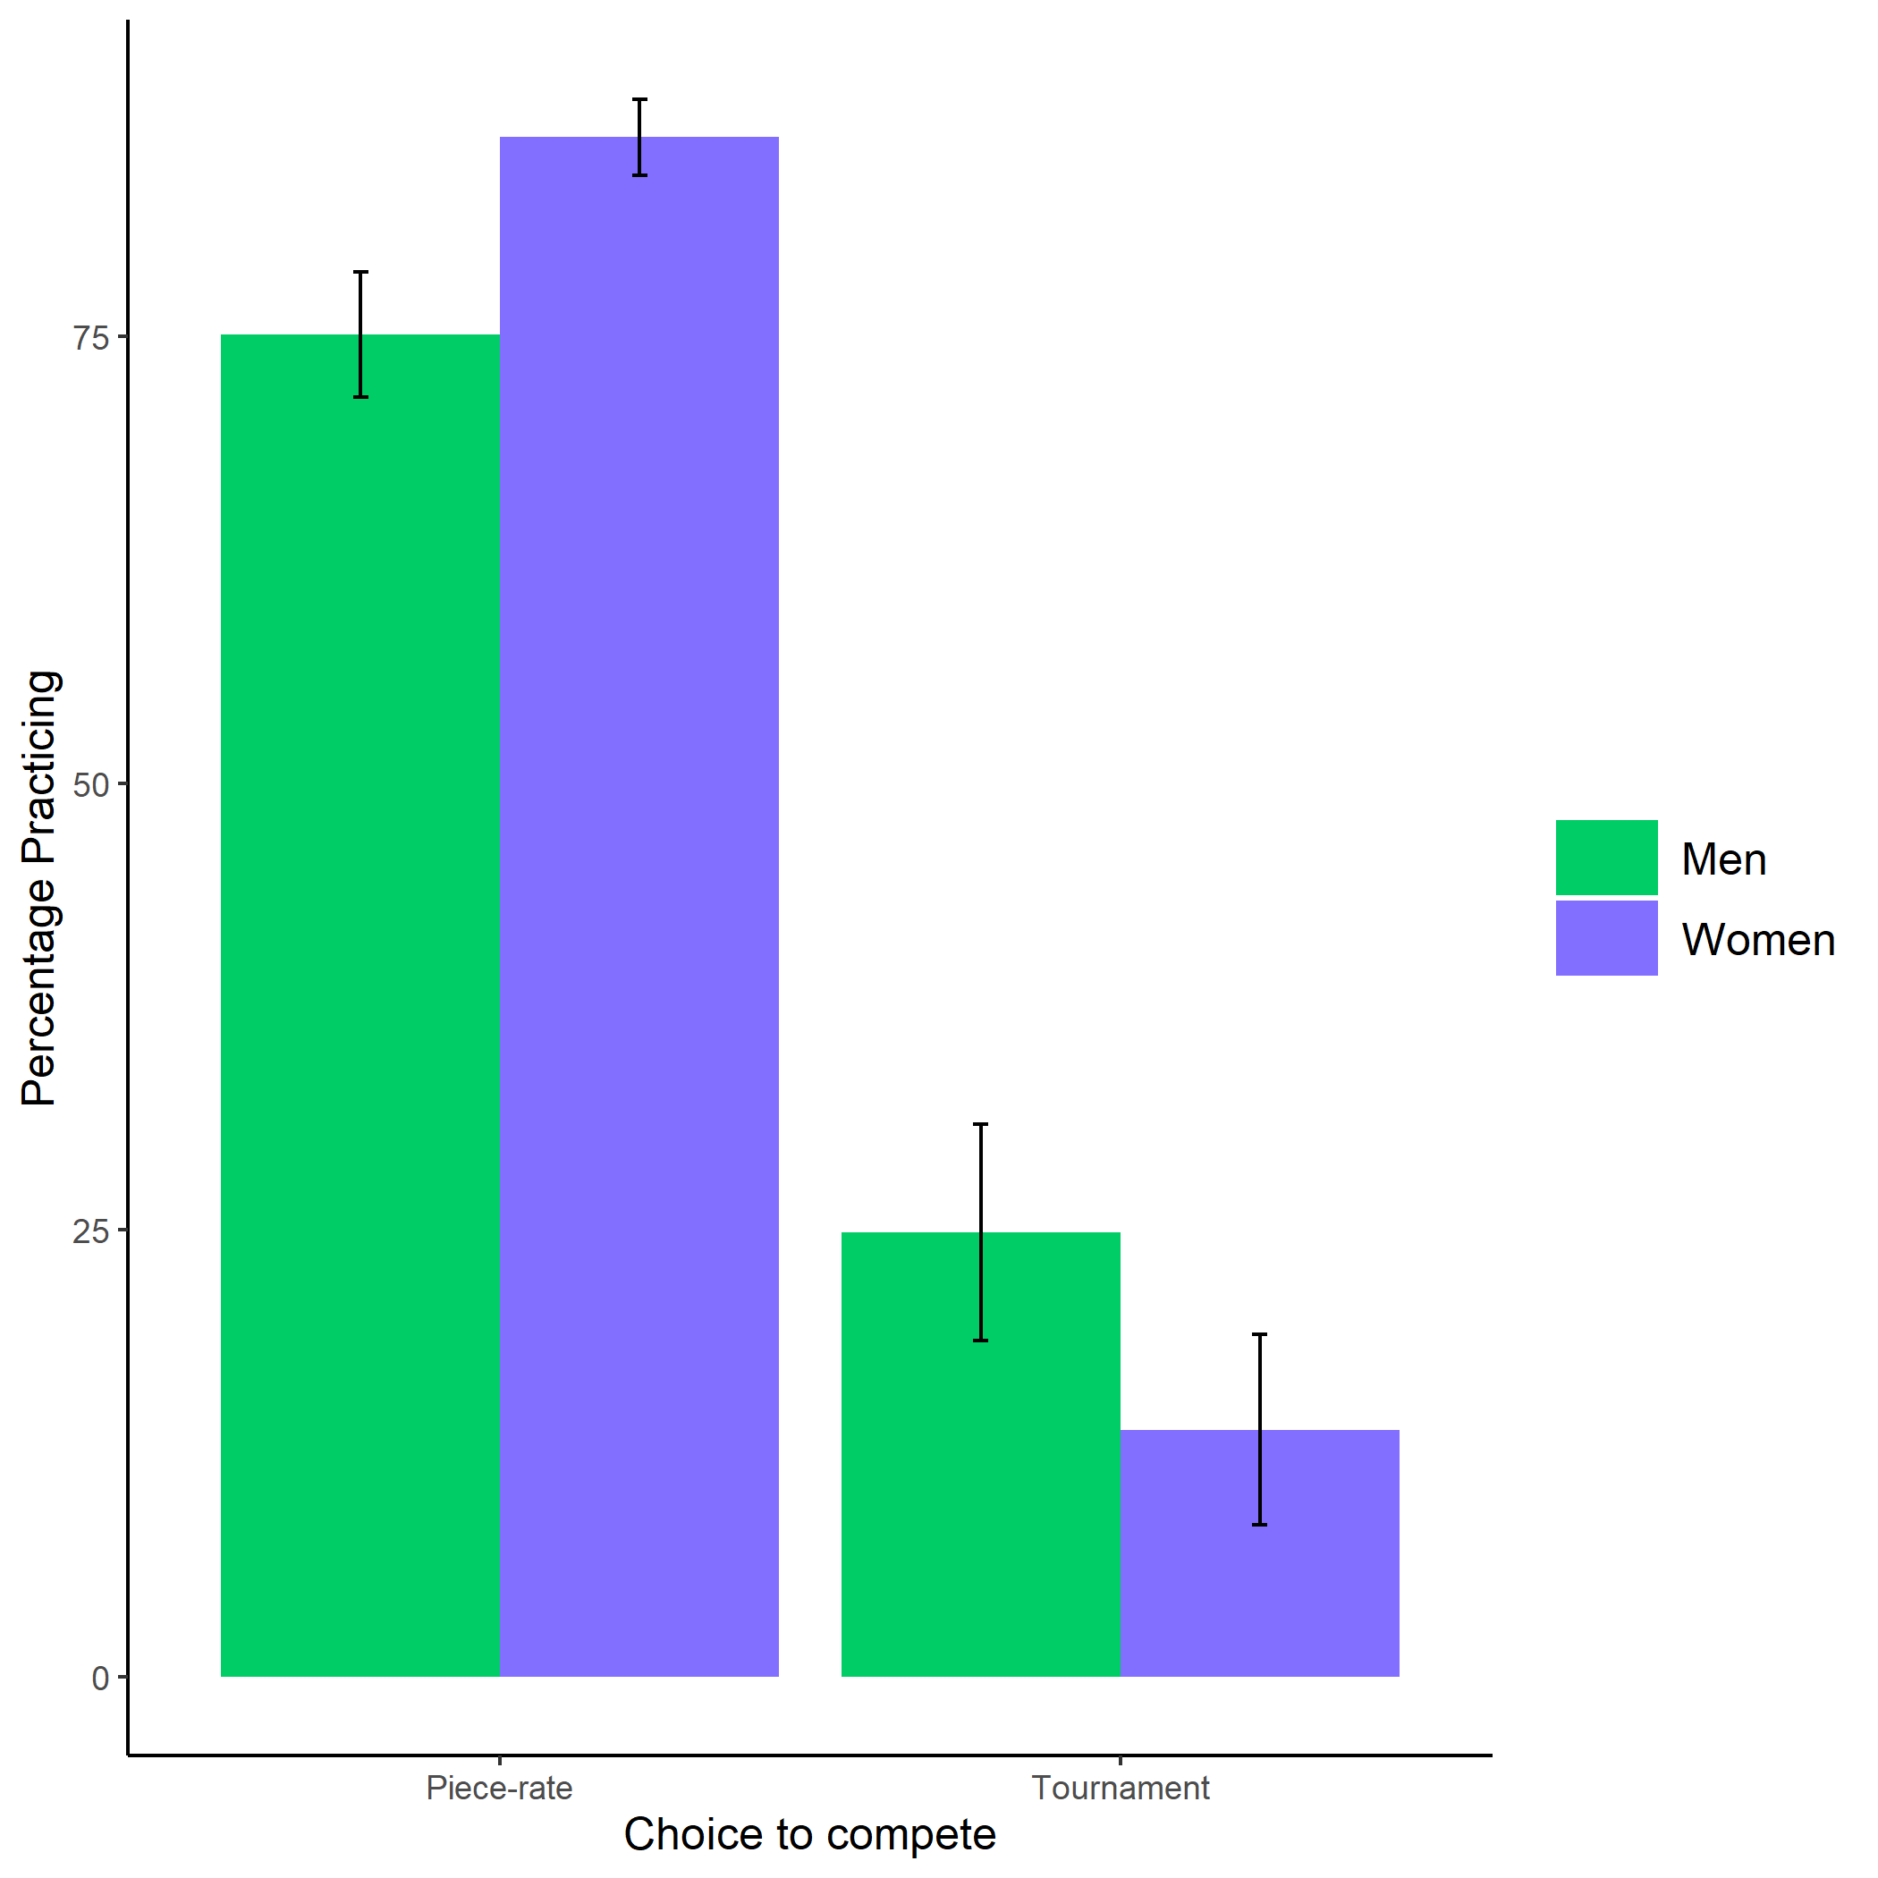

*Figure* *2.*  Proportion of male and female participants who chose to prepare by choice to compete. Women are significantly more willing to prepare, even before they know what the preparation involves. This finding holds regardless of whether women chose to follow a competitive or non-competitive payment scheme. That is, there is no interaction between gender and choice to compete on the decision to prepare. Error bars represent standard errors.

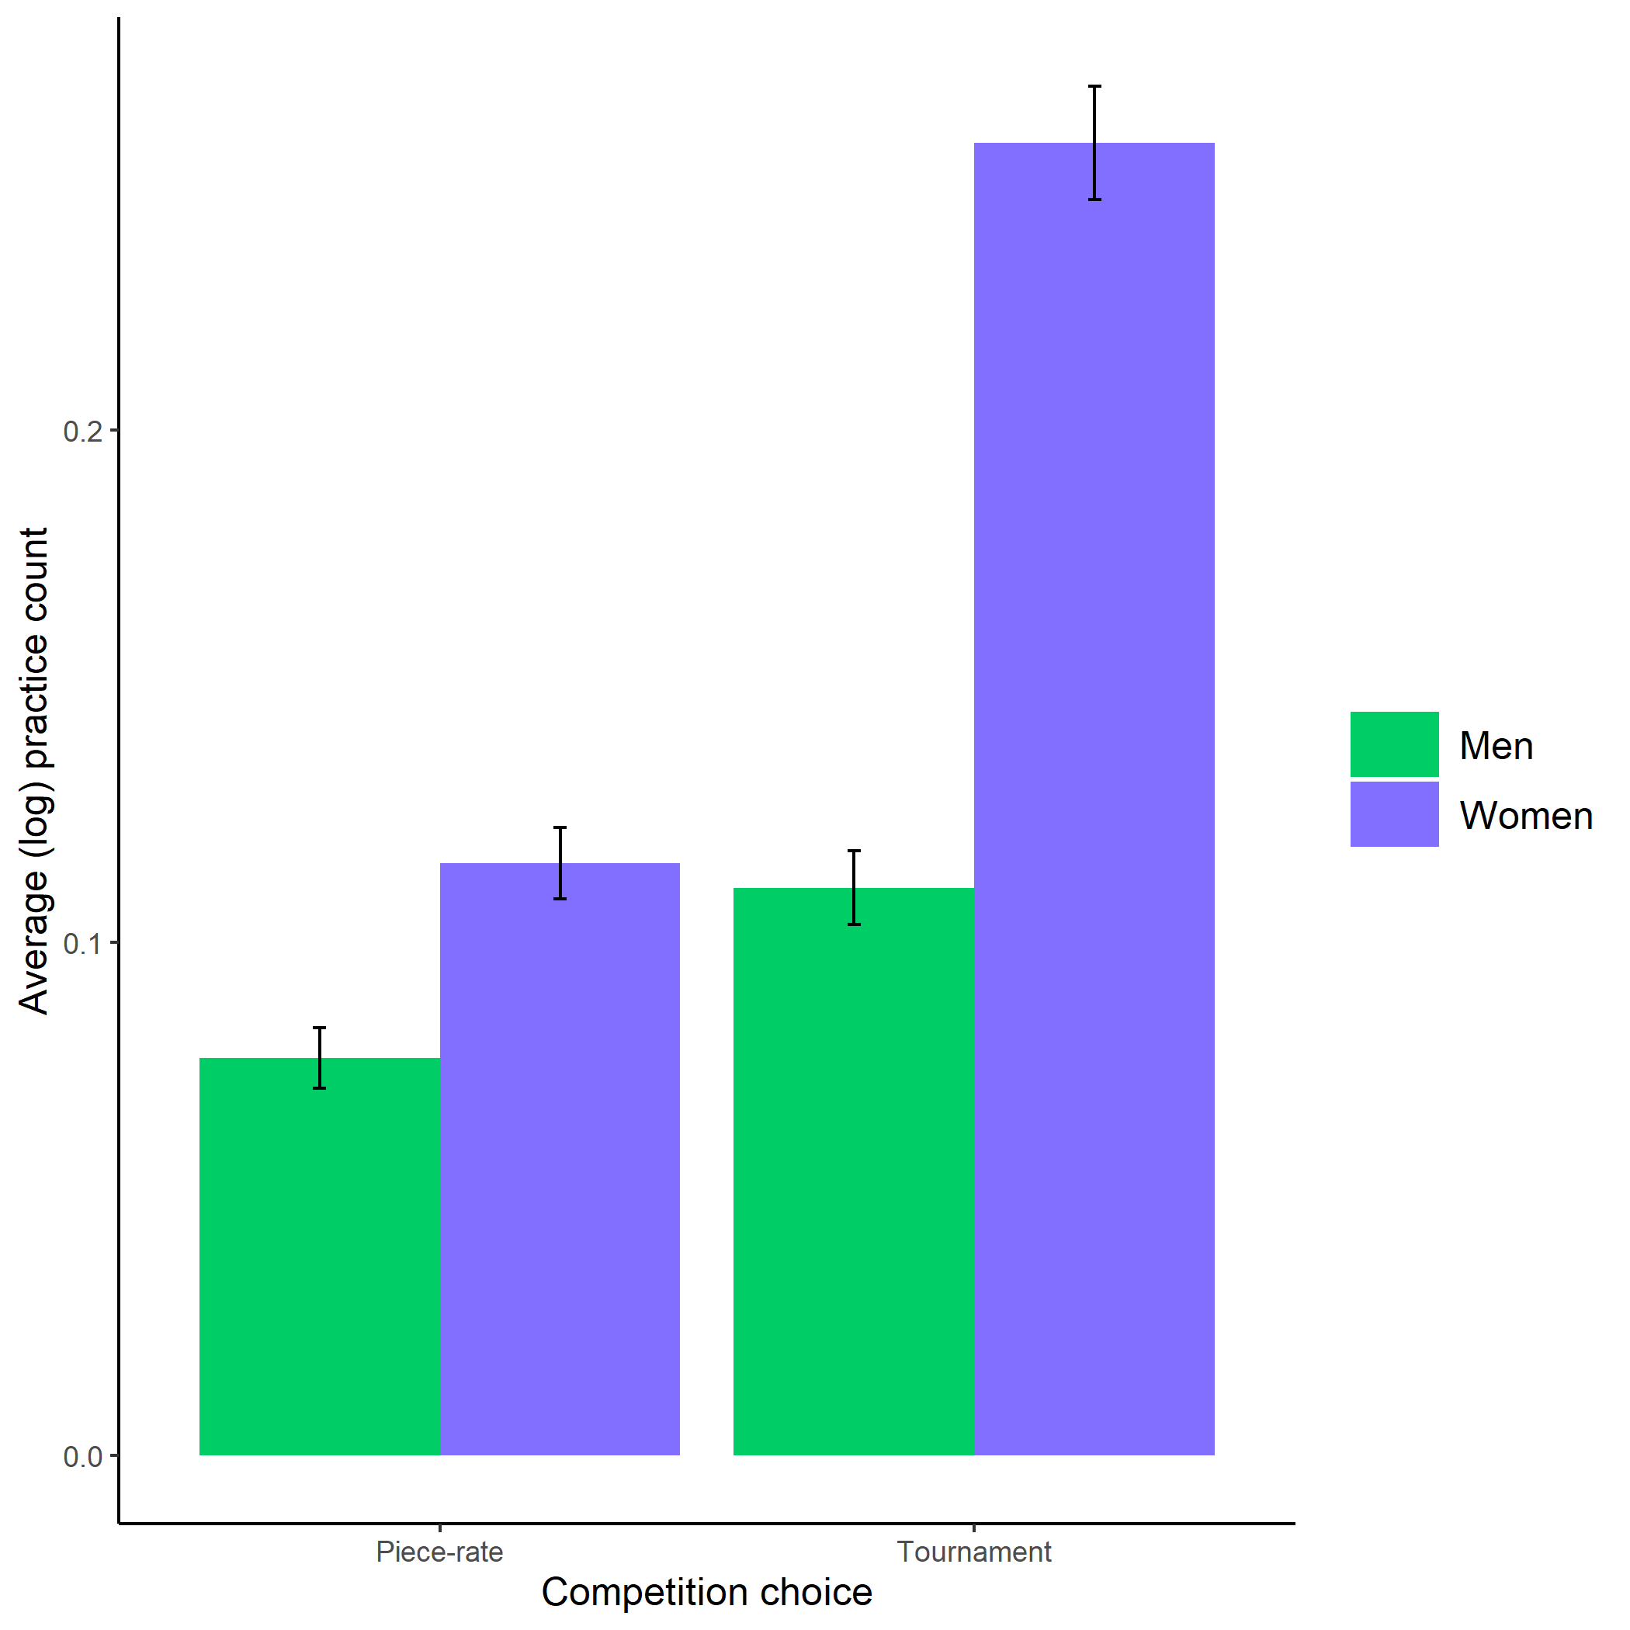

*Figure* *3.*  Average (log-transformed) practice count based on participant gender and competition choice. We find further evidence of a gender difference in the choice to prepare using a different metric of the choice to prepare: the number of times a participant chooses to persist in their practice effort by repeatedly practicing. Here, we find evidence of a significant interaction between gender and the choice to compete on the choice to practice, where women who chose to compete are significantly more likely to practice. However, the small size of this cell must be considered when interpreting this interaction. Future research is needed to ensure this effect replicates. Error bars represent standard errors.

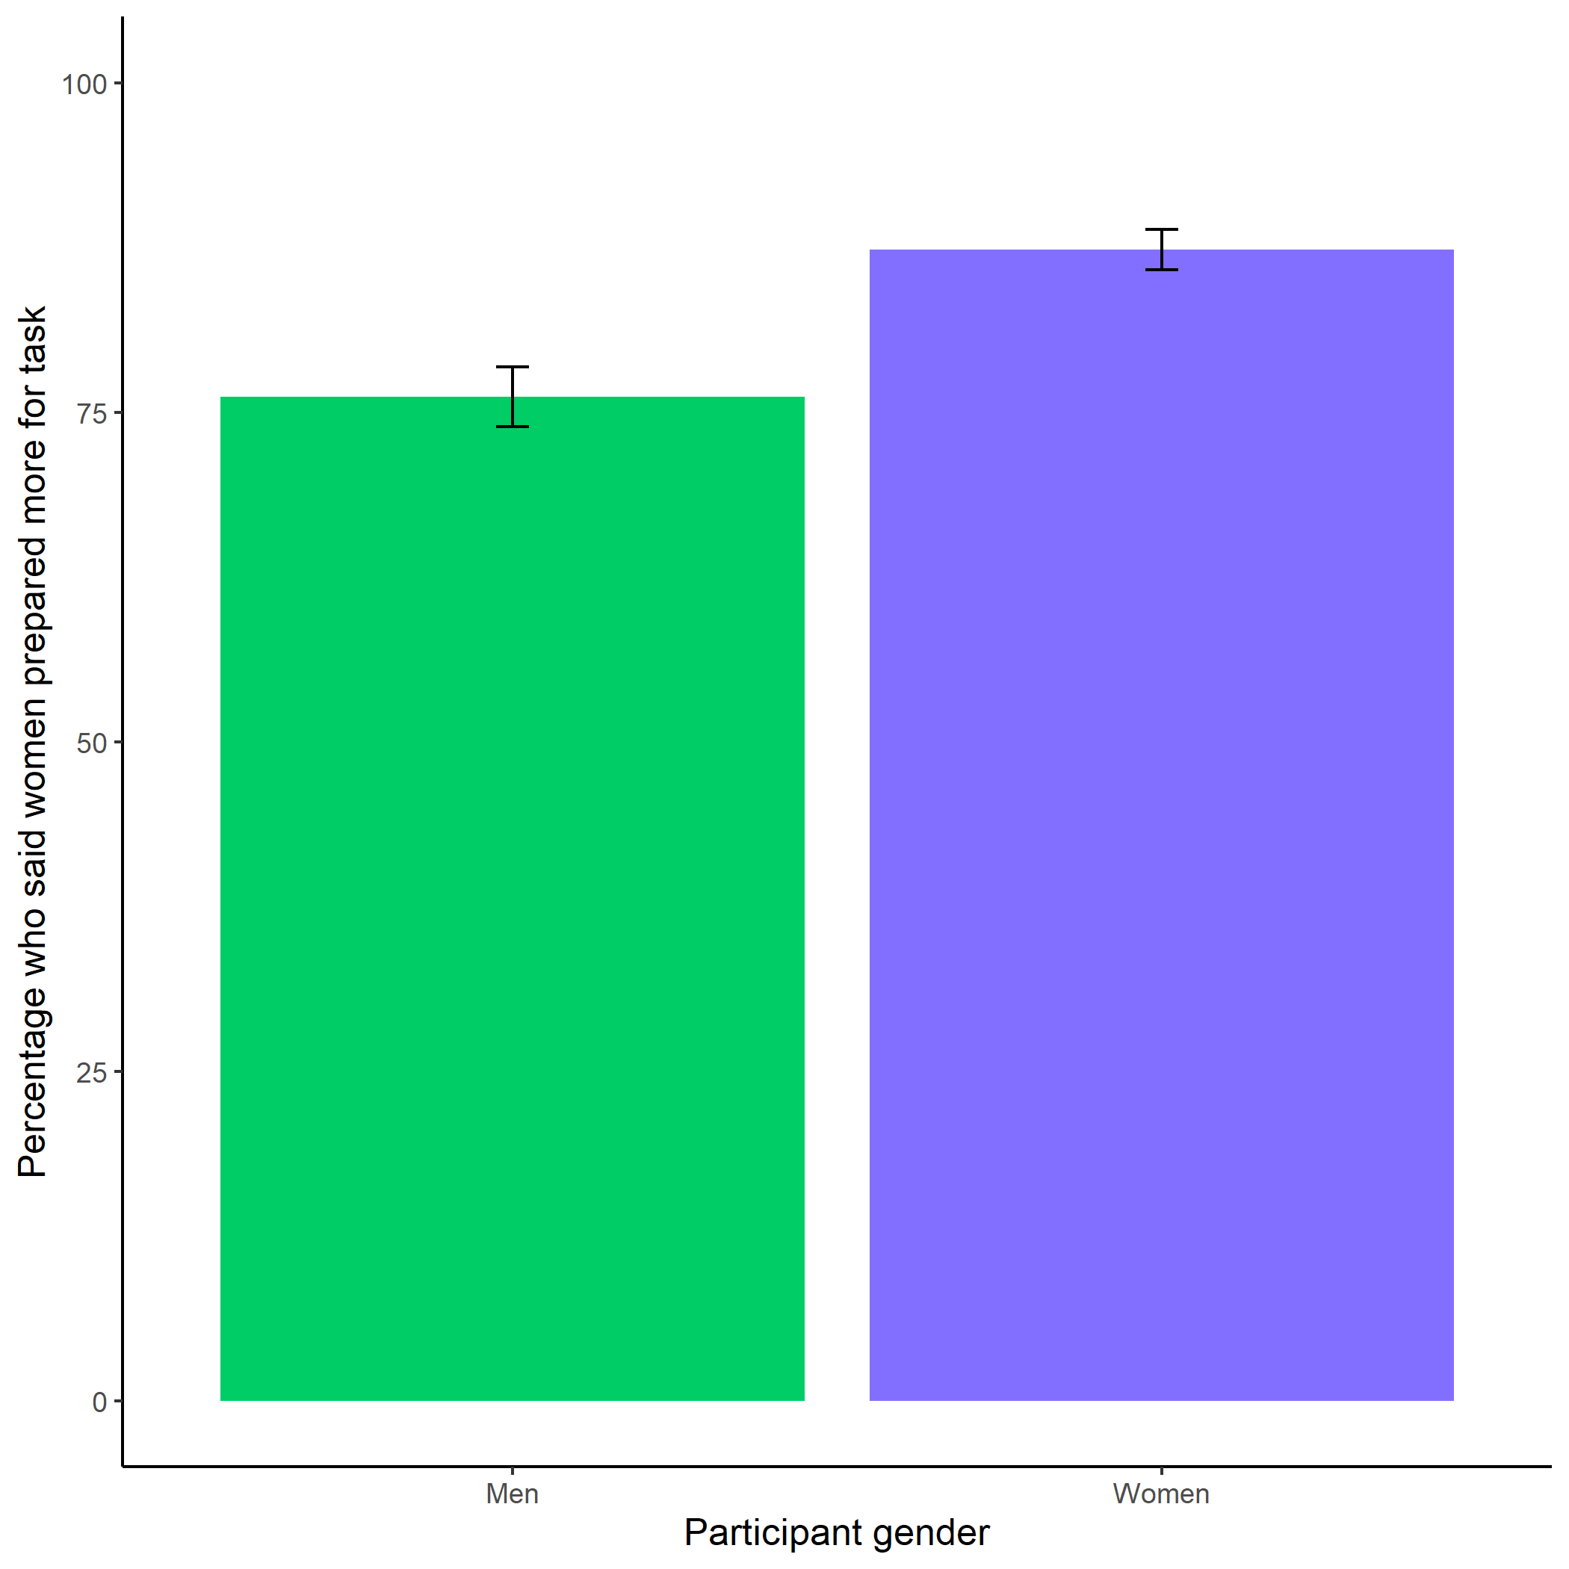

*Figure* *4.*  Participants’ perceptions of gender differences in the choice to practice on the task. Both men and women correctly anticipate that women will be more willing to practice before completing the multiplication task. Women are especially likely to state women will prepare more for the task. Error bars represent standard errors.

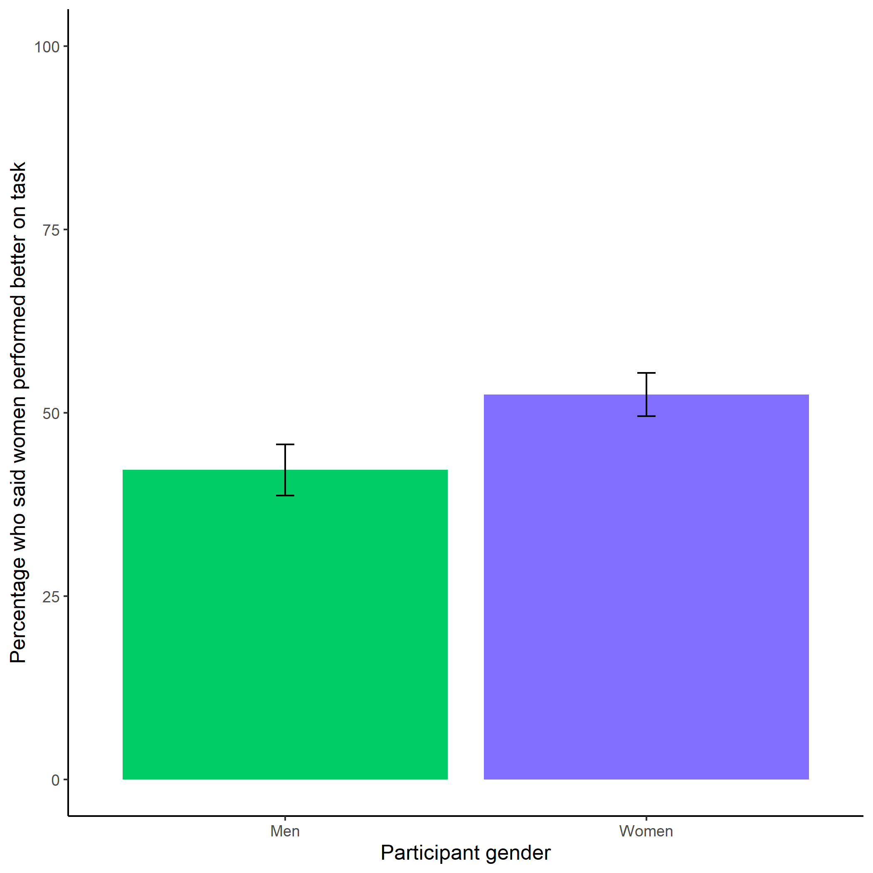

*Figure* *5.*  Participants’ perceptions of gender differences in performance on the task. Participants were equally likely to predict that women (vs. men) would perform better on the task, suggesting that participants did not have strong stereotypes about gender differences in performance on the multiplication task. Error bars represent standard errors.

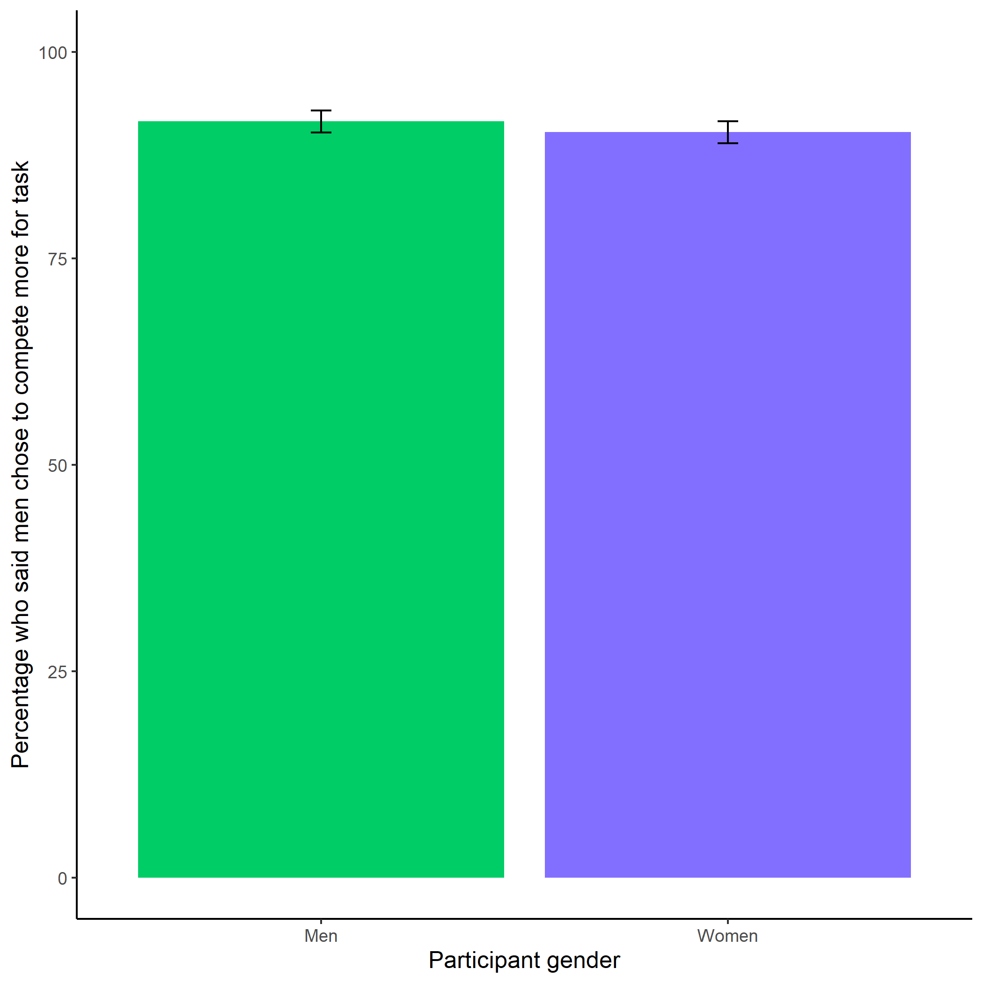

*Figure* *6.*  Participants’ perceptions of gender differences in choice to compete. Both men and women were significantly more likely than chance to correctly state that men would be more likely to choose to compete during the multiplication task, suggesting strong stereotypes about gender differences in competitiveness. Error bars represent standard errors.

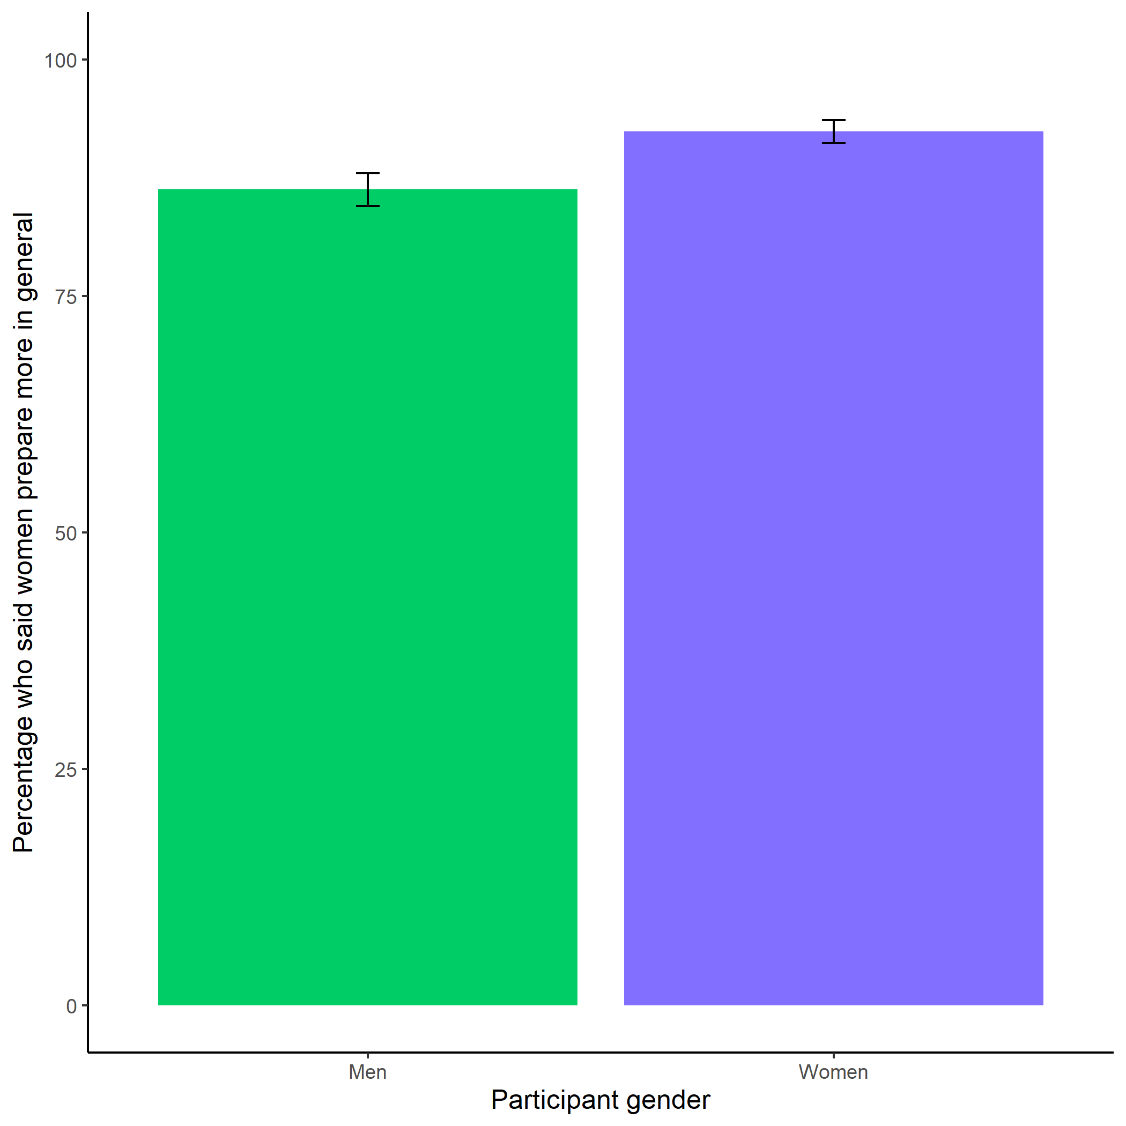

*Figure* *7.*  Participants’ perceptions of general gender differences in choice to practice. Both men and women (but especially women) were significantly more likely to say that women prepare more in general than men. Again, these findings suggest that participants observe these gender differences directly or are aware of stereotypes about gender differences in the choice to prepare. Error bars represent standard errors.

## 5.2 Study 2

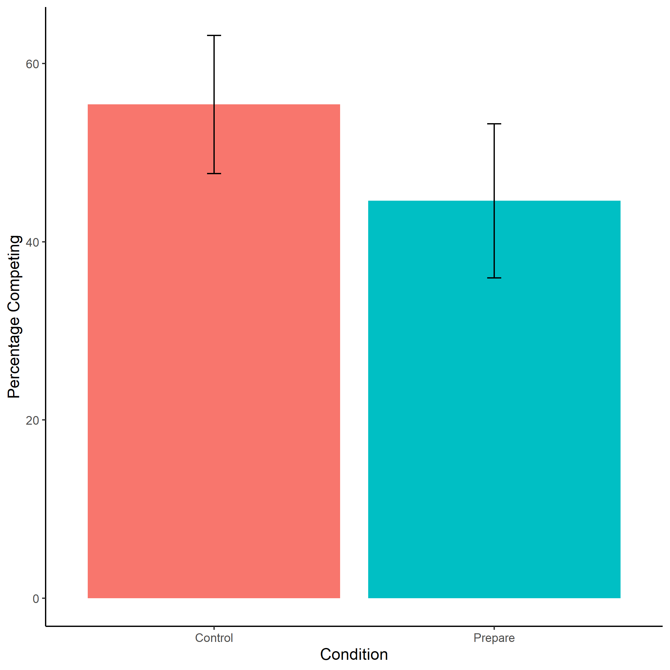

*Figure* *8.*  Proportion of female participants who chose to compete by condition. We do not find evidence of the hypothesized effect of condition on the choice to compete, there were no significant differences in entry into competition between women in the control vs. prepare conditions. Error bars represent standard errors.

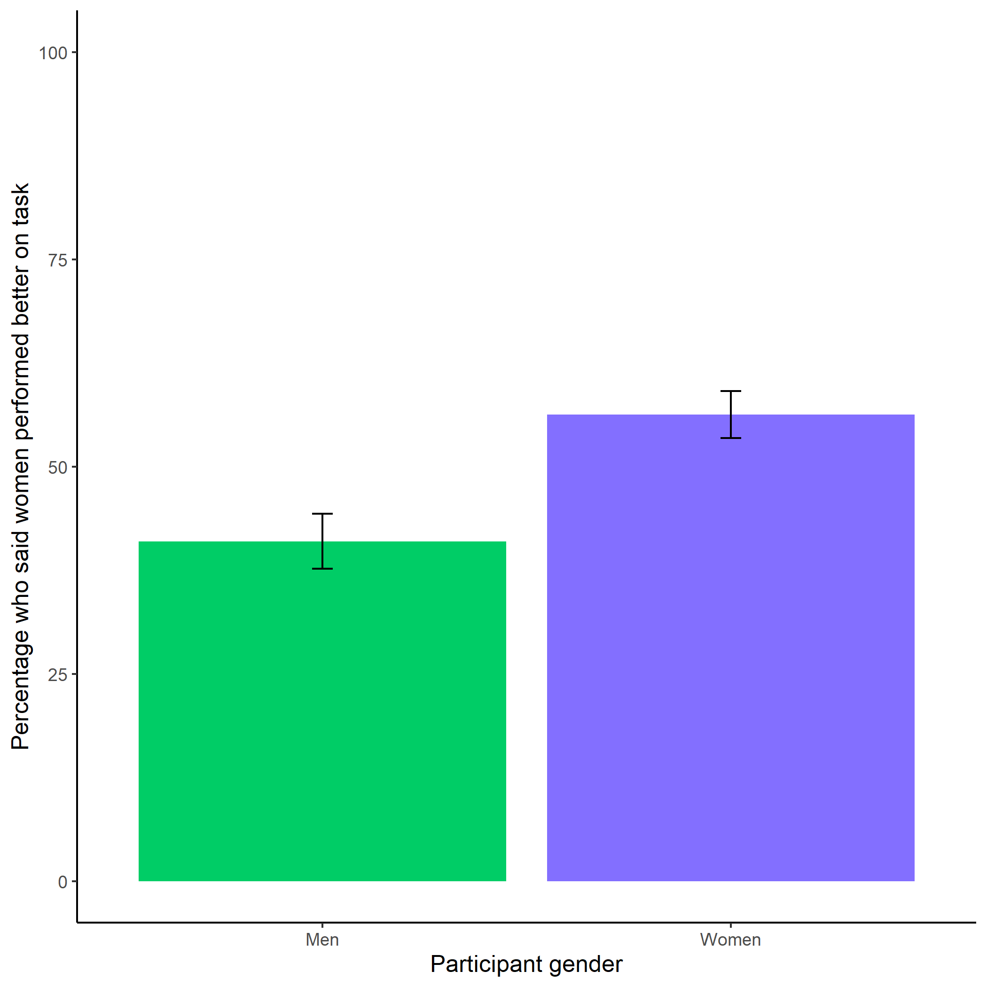

*Figure* *9.*  Participants’ perceptions of gender differences in performance on the task. We replicate the effect from Study 1, where participants were not significantly more likely to anticipate that one gender would perform better on the task. Error bars represent standard errors.

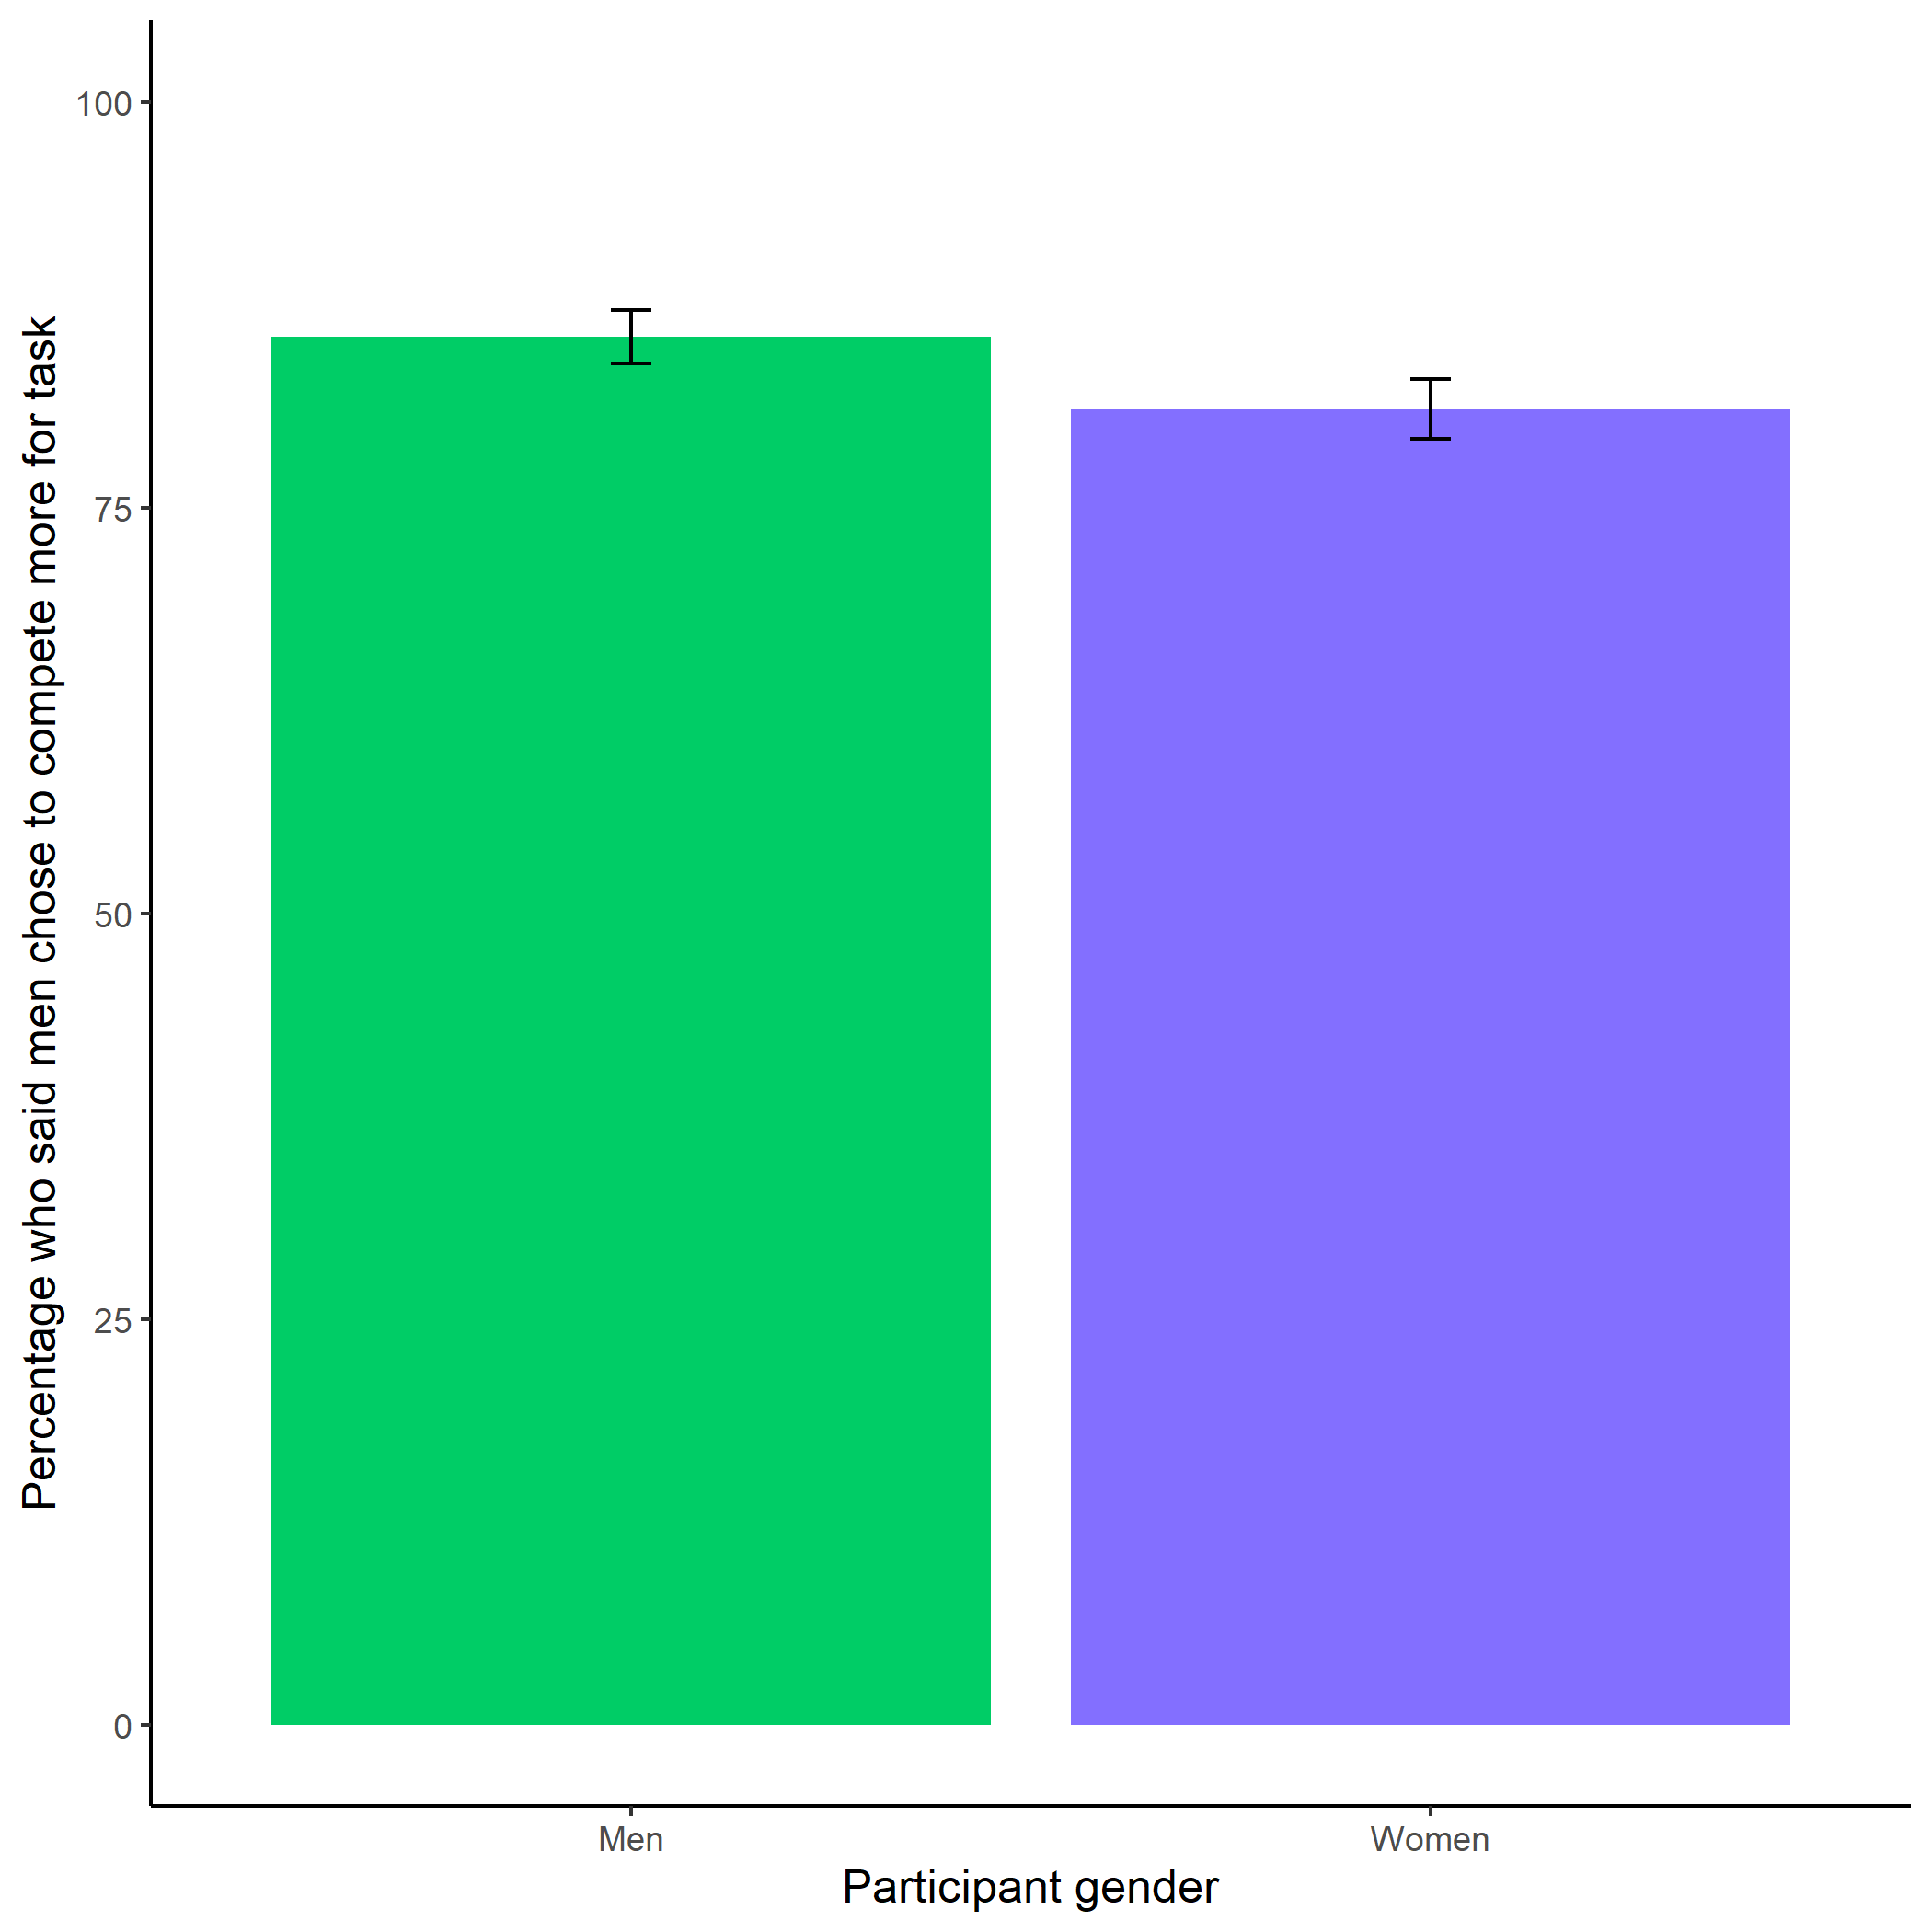

*Figure* *10.*  Participants’ perceptions of gender differences in choice to compete. Replicating the finding from Study 1, participants (especially men) in Study 2 are significantly more likely to state that men chose the competitive payment scheme. Error bars represent standard errors.

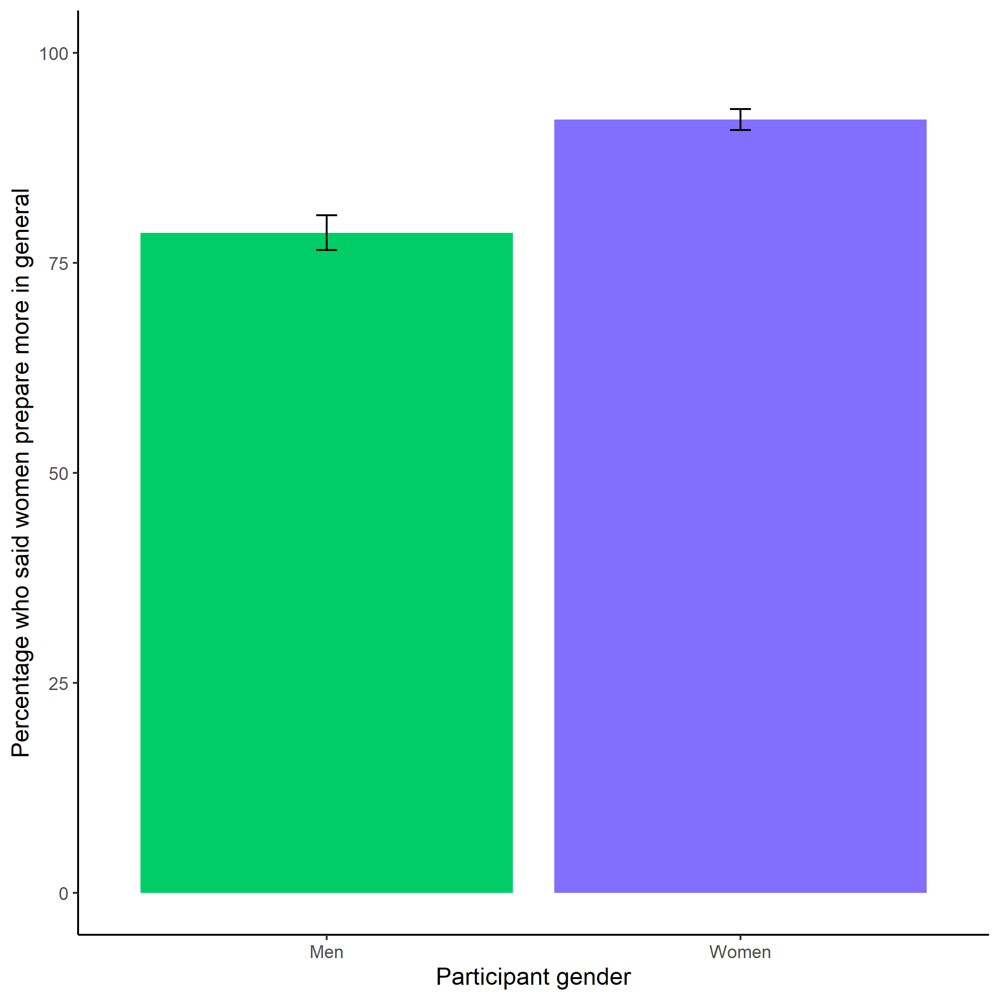

*Figure* *11.*  Participants’ perceptions of general gender differences in choice to prepare. We replicate the findings from Study 1, where participants (especially women) are significantly more likely to state that women prepare more in general than men. Error bars represent standard errors.

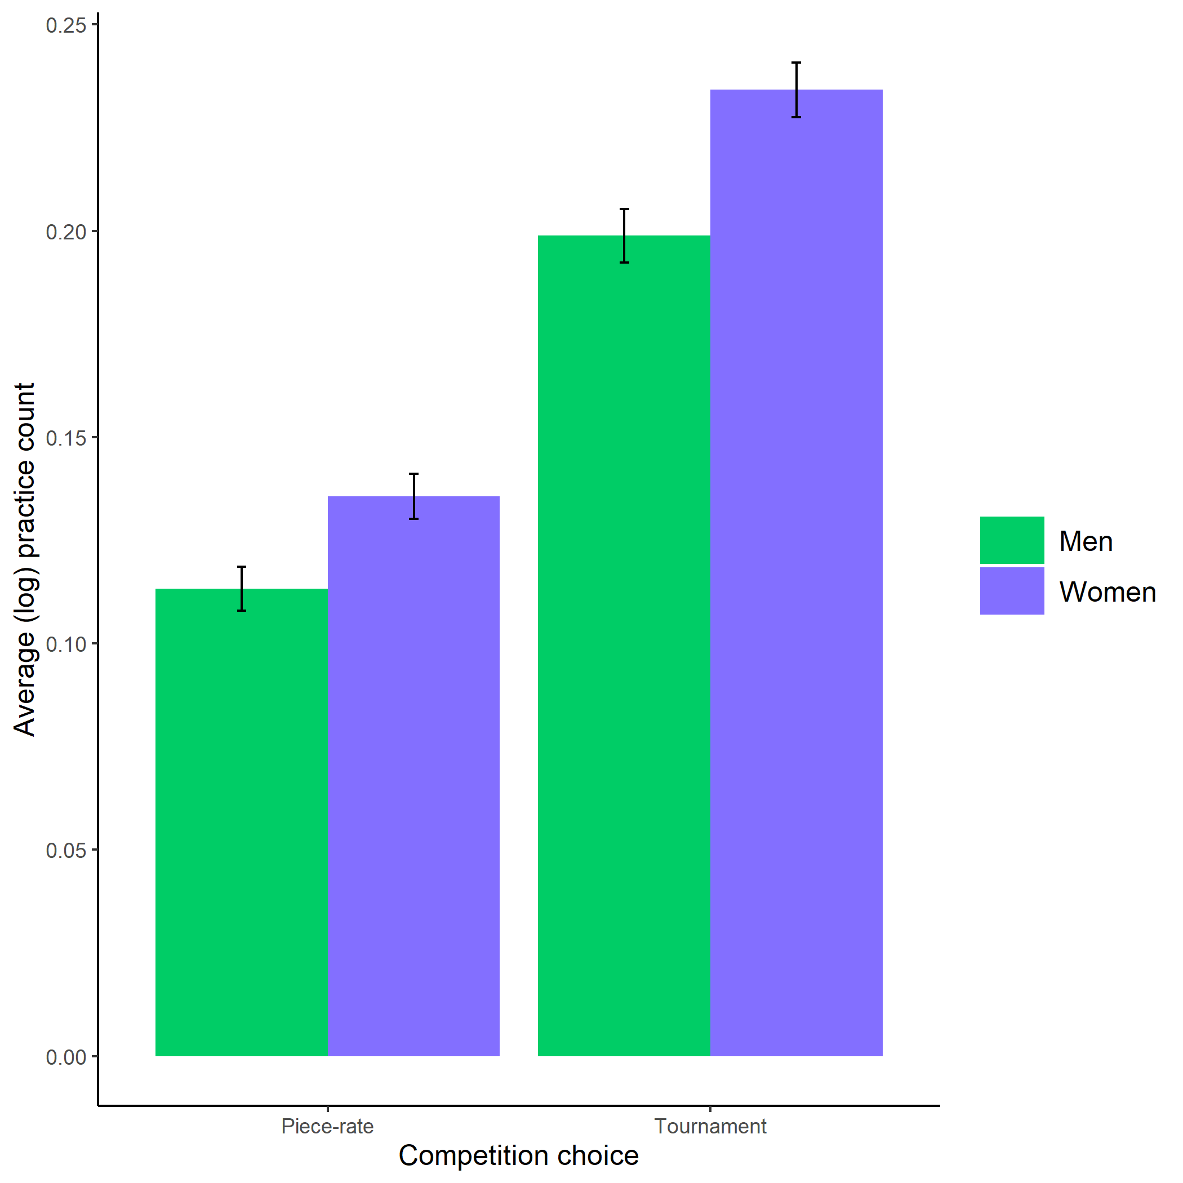

*Figure* *12.*  Gender differences in the number of extra preparation rounds chosen across participants’ choice in a payment scheme. Here, we show that the gender gap in the choice to prepare is robust, even when half of the women are forced to prepare in the preparation condition. Error bars represent standard errors.

# 6 References

Akerlof, G. A., & Kranton, R. E. (2000). Economics and identity. *The Quarterly Journal of Economics*, *115*(3), 715–753.

Altonji, J. G., & Blank, R. M. (1999). Race and gender in the labor market. In *Handbook of labor economics* (pp. 3143–3259).

Andersen, S., Ertac, S., Gneezy, U., List, J. A., & Maximiano, S. (2013). Gender, competitiveness, and socialization at a young age: Evidence from a matrilineal and a patriarchal society. *Review of Economics and Statistics*, *95*(4), 1438–1443.

Apicella, C. L., Crittenden, A. N., & Tobolsky, V. A. (2017a). Hunter-gatherer males are more risk-seeking than females, even in late childhood. *Evolution and Human Behavior*, *38*, 592–603.

Apicella, C. L., Demiral, E. E., & Mollerstrom, J. (2017b). No gender difference in willingness to compete when competing against self. *DIW Discussion Papers*.

Apicella, C. L., & Dreber, A. (2015). Sex differences in competitiveness: Hunter-gatherer women and girls compete less in gender-neutral and male-centric tasks. *Adaptive Human Behavior and Physiology*, *1*(3), 247–269. <https://doi.org/10.1007/s40750-014-0015-z>

Babcock, L., Bowles, H. R., & Bear, J. (2012). A model of when to negotiate: Why women don’t ask. In *The oxford handbook of economic conflict resolution* (pp. 313–331). <https://doi.org/10.1093/oxfordhb/9780199730858.013.0022>

Bandura, A., Adams, N. E., & Beyer, J. (1977). Cognitive processes mediating behavioral change. *Journal of Personality and Social Psychology*, *35*(3), 125–139.

Barber, B. M., & Odean, T. (2001). Boys will be boys: Gender, overconfidence, and common stock investment. *The Quarterly Journal of Economics*, *116*(1), 261–292.

Benjamin, D. J., Choi, J. J., & Strickland, A. J. (2010). Social identity and preferences. *American Economic Review*, *100*(4), 1913–1928. <https://doi.org/10.1257/aer.100.4.1913>

Berge, L. I. O., Bjorvatn, K., Garcia Pires, A. J., & Tungodden, B. (2015). Competitive in the lab, successful in the field? *Journal of Economic Behavior and Organization*, *118*, 303–317. <https://doi.org/10.1016/j.jebo.2014.11.014>

Bertrand, M. (2010). New Perspectives on Gender. In *Handbook of labor economics* (Vol. 4b, pp. 1545–1592).

Bertrand, M., Goldin, C., & Katz, L. F. (2010). Dynamics of the gender gap for young professionals in the financial and corporate sectors. *American Economic Review*, *2*(3), 228–255.

Bertrand, M., & Hallock, K. F. (2001). The gender gap in top corporate jobs. *Industrial and Labor Relations Review*, *55*, 3–21.

Bertrand, M., Kamenica, E., & Pan, J. (2015). Gender identity and relative income within households. *Quarterly Journal of Economics*, 571–614. <https://doi.org/10.1093/qje/qjv001.Advance>

Beyer, S. (1990). Gender differences in the accuracy of self-evaluations of performance. *Journal of Personality and Social Psychology*, *59*(5), 960–970. <https://doi.org/10.1037/0022-3514.59.5.960>

Beyer, S., & Bowden, E. M. (1997). Gender differences in self-perceptions: Convergent evidence from three measures of accuracy and bias. *Personality and Social Psychology Bulletin*, *23*(2), 157–172.

Bjorvatn, K., Falch, R., & Hernæs, U. (2016). Gender, context and competition: Experimental evidence from rural Uganda. *Journal of Behavioral and Experimental Economics*, *61*, 31–37.

Blau, F. D., & Kahn, L. M. (2017). The gender wage gap: Extent, trends, and explanations. *Journal of Economic Literature*, *55*(3), 789–865. <https://doi.org/10.1257/jel.20160995>

Boschini, A., Dreber, A., Essen, E. V., Muren, A., & Ranehill, E. (2019). Gender, risk preferences and willingness to compete in a random sample of the Swedish population. *Journal of Behavioral and Experimental Economics*, *83*(September), 101467. <https://doi.org/10.1016/j.socec.2019.101467>

Boschini, A., Dreber, A., Essen, E. von, Muren, A., & Ranehill, E. (2014). Gender and economic preferences in a large random and representative sample. *SSRN Electronic Journal*. <https://doi.org/10.2139/ssrn.2443315>

Bowles, H. R., Babcock, L., & Lai, L. (2007). Social incentives for gender differences in the propensity to initiate negotiations: Sometimes it does hurt to ask. *Organizational Behavior and Human Decision Processes*, *103*, 84–103. <https://doi.org/10.1016/j.obhdp.2006.09.001>

Buser, T., Niederle, M., & Oosterbeek, H. (2014). Gender, competition and career choices. *The Quarterly Journal of Economics*, *129*(3), 1409–1447. <https://doi.org/10.1093/qje/qju009.Advance>

Buser, T., Peter, N., & Wolter, S. C. (2017). Gender, competitiveness, and study choices in high school: Evidence from Switzerland. *American Economic Review: Papers & Proceedings*, *107*(5), 125–130.

Cheryan, S., Ziegler, S. A., Montoya, A. K., & Jiang, L. (2017). Why are some stem fields more gender balanced than others? *Psychological Bulletin*, *143*(1), 1–35.

Croson, R., & Gneezy, U. (2009). Gender differences in preferences. *Journal of Economic Literature*, *47*(2), 448–474. <https://doi.org/10.1257/jel.47.2.448>

Dohmen, T., & Falk, A. (2011). Performance pay and multidimensional sorting: Productivity, preferences, and gender. *American Economic Association*, *101*(2), 556–590. <https://doi.org/http://dx.doi.org/10.1016/j.poly.2014.08.015>

Dohmen, T., Falk, A., Huffman, D., Sunde, U., Schupp, J., & Wagner, G. G. (2011). Individual risk attitudes: Measurement, determinants, and behavioral consequences. *Journal of the European Economic Association*, *9*(3), 522–550. <https://doi.org/10.1111/j.1542-4774.2011.01015.x>

Dreber, A., Essen, E. V., & Ranehill, E. (2011). Outrunning the gender gap — boys and girls compete equally. *Experimental Economics*, *14*(4), 567–582. <https://doi.org/10.1007/s10683-011-9282-8>

Dreber, A., Essen, E. V., & Ranehill, E. (2014). Gender and competition in adolescence: Task matters. *Experimental Economics*, *17*, 154–172. <https://doi.org/10.1007/s10683-013-9361-0>

Eckel, C. C., & Grossman, P. J. (2008). Men, women, and risk aversion: Experimental evidence. In *Handbook of experimental economics* (Vol. 1, pp. 1061–1073). <https://doi.org/10.1016/S1574-0722(07)00113-8>

Flory, J. A., Leibbrandt, A., & List, J. A. (2010). Do competitive work places deter female workers? A large-scale natural field experiment on gender differences in job-entry decisions. *NBER Working Paper Series*, 1–57. <https://doi.org/10.3386/w16546>

Frank, R. H., & Cook, P. J. (2010). *The winner-take-all society: Why the few at the top get so much more than the rest of us*.

Frick, B. (2011). Gender differences in competitiveness: Empirical evidence from professional distance running. *Labour Economics*, *18*(3), 389–398. <https://doi.org/10.1016/j.labeco.2010.11.004>

Gaucher, D., Friesen, J., & Kay, A. C. (2011). Evidence that gendered wording in job advertisements exists and sustains gender inequality. *Journal of Personality and Social Psychology*, *101*(1), 109–128. <https://doi.org/10.1037/a0022530>

Gillen, B., Snowberg, E., & Yariv, L. (2019). Experimenting with measurement error: Techniques with applications to the Caltech cohort study. *Journal of Political Economy*, *127*(4), 1826–1863.

Gist, M. E., & Mitchell, T. R. (1992). Self-efficacy: A theoretical analysis of its determinants and malleability. *The Academy of Management Review*, *17*(2), 183–211.

Goldin, C., Katz, L. F., & Kuziemko, I. (2006). The homecoming of American college women: The reversal of the college gender gap. *Journal of Economic Perspectives*, *20*(4), 133–156. <https://doi.org/10.1257/jep.20.4.133>

Grosse, N., & Riener, G. (2010). Explaining gender differences in competitiveness: Gender-task stereotypes. *Jena Economic Research Papers*.

Günther, C., Ekinci, N. A., Schwieren, C., & Strobel, M. (2010). Women can’t jump?-An experiment on competitive attitudes and stereotype threat. *Journal of Economic Behavior and Organization*, *75*(3), 395–401. <https://doi.org/10.1016/j.jebo.2010.05.003>

Hirt, E. R., & Mccrea, S. M. (2009). Man smart, woman smarter ? Getting to the root of gender differences in self-handicapping. *Social and Personality Psychology Compass*, *3*, 260–274.

Iriberri, N., & Rey-Biel, P. (2017). Stereotypes are only a threat when beliefs are reinforced: On the sensitivity of gender differences in performance under competition to information provision. *Journal of Economic Behavior and Organization*, *135*, 99–111.

Kahneman, D., & Tversky, A. (1982). The psychology of preferences. *Scientific American*, *246*(1), 160–173.

Kenney-Benson, G. A., Pomerantz, E. M., Ryan, A. M., & Patrick, H. (2006). Sex differences in math performance: The role of children’s approach to schoolwork. *Developmental Psychology*, *42*(1), 11–26. <https://doi.org/10.1037/0012-1649.42.1.11>

Kimble, C. E., & Hirt, E. R. (2005). Self-focus, gender, and habitual self-handicapping: Do they make a difference in behavioral self-handicapping? *Social Behavior and Personality*, *33*(1), 43–56.

Lavy, V. (2004). Performance pay and teachers’ effort, productivity and grading ethics. *NBER WORKING PAPER SERIES*.

Lemieux, T., MacLeod, B. W., & Parent, D. (2009). Performance pay and wage inequality. *The Quarterly Journal of Economics*, *CXXIV*(1), 1–49.

Lent, R. W., Brown, S. D., Gover, M. R., & Nijjer, S. K. (1996). Cognitive assessment of the sources of mathematics self-efficacy: A thought-listing analysis. *Journal of Career Assessment*, *4*(1), 33–46. <https://doi.org/10.1177/106907279600400102>

Leslie, S.-J., Cimpian, A., Meyer, M., & Freeland, E. (2015). Expectations of brilliance underlie gender distributions across academic disciplines. *Science*, *347*(6219), 23–34. <https://doi.org/10.1081/E-EWS>

Lundeberg, M. A., Fox, P. W., & Puncochaf, J. (1994). Highly confident but wrong: Gender differences and similarities in confidence judgments. *Journal of Educational Psychology*, *86*(1), 114–121.

Mayr, U., Wozniak, D., Davidson, C., Kuhns, D., & Harbaugh, W. T. (2012). Competitiveness across the life span: The feisty fifties. *Psychology and Aging*, *27*(2), 278–285. <https://doi.org/10.1037/a0025655>

Mccrea, S. M., Hirt, E. R., Hendrix, K. L., Milner, B. J., & Steele, N. L. (2008a). The worker scale: Developing a measure to explain gender differences in behavioral self-handicapping. *Journal of Research in Personality*, *42*, 949–970. <https://doi.org/10.1016/j.jrp.2007.12.005>

Mccrea, S. M., Hirt, E. R., & Milner, B. J. (2008b). She works hard for the money: Valuing effort underlies gender differences in behavioral self-handicapping. *Journal of Experimental Social Psychology*, *44*, 292–311. <https://doi.org/10.1016/j.jesp.2007.05.006>

Meyer, M., Cimpian, A., & Leslie, S.-J. (2015). Women are underrepresented in fields where success is believed to require brilliance. *Frontiers in Psychology*, *6*, 1–12. <https://doi.org/10.3389/fpsyg.2015.00235>

Milyavskaya, M., Galla, B. M., Inzlicht, M., & Duckworth, A. (2018). More effort, less fatigue: How interest increases effort and reduces mental fatigue.

Mobius, M. M., Niederle, M., Niehaus, P., & Rosenblat, T. S. (2011). Managing self-confidence: Theory and experimental evidence. *NBER Working Paper*.

Niederle, M., & Vesterlund, L. (2007). Do women shy away from competition? Do men compete too much? *The Quarterly Journal of Economics*, *122*(3), 1067–1101. Retrieved from [https://web.stanford.edu/{~}niederle/Niederle.Vesterlund.QJE.2007.pdf](https://web.stanford.edu/%7B~%7Dniederle/Niederle.Vesterlund.QJE.2007.pdf)

Niederle, M., & Vesterlund, L. (2011). Gender and competition. *Annual Review of Economics*, *3*, 601–630. <https://doi.org/10.1016/j.labeco.2009.08.002>

Reuben, E., Sapienza, P., & Zingales, L. (2015). Taste for competition and the gender gap among young business professionals. *NBER WORKING PAPER SERIES*.

Saccardo, S., Pietrasz, A., & Gneezy, U. (2018). On the size of the gender difference in competitiveness. *Management Science*, *64*(4), 1541–1554.

Samek, A. (2019). Gender differences in job entry decisions: A university- wide field experiment. *Management Science*, *65*(7), 3272–3281.

Schultz, P. W., Nolan, J. M., Cialdini, R. B., Goldstein, N. J., & Griskevicius, V. (2018). The constructive, destructive, and reconstructive power of social norms: Reprise. *Psychological Science*, *13*(2), 249–254. <https://doi.org/10.1111/j.1467-9280.2007.01917.x>

Schunk, D. H. (1981). Modeling and Attributional Effects on Children’s Achievement: A Self-Efficacy Analysis. *Journal of Educational Psychology*, *73*(1), 93–105.

Schunk, D. H. (1982). Progress Self-Monitoring: Effects on Children’s Self-Efficacy and Achievement. *The Journal of Experimental Education*, *51*(2), 89–93.

Shurchkov, O. (2012). Under pressure: Gender differences in output quality and quantity under competition and time constraints. *Journal of the European Economic Association*, *10*(5), 1189–1213.

Smith, J. L., & Huntoon, M. (2014). Women’s Bragging Rights: Overcoming Modesty Norms to Facilitate Women’s. *Psychology of Women Quarterly*, *38*(4), 447–459. <https://doi.org/10.1177/0361684313515840>

Spencer, S. J., Logel, C., & Davies, P. G. (2016). Stereotype Threat. *Annual Review of Psychology*, *67*(1), 415–437. <https://doi.org/10.1146/annurev-psych-073115-103235>

Spencer, S. J., Steele, C. M., & Quinn, D. M. (1999). Stereotype threat and women’s math performance. *Journal of Experimental Social Psychology*, *35*(1), 4–28. <https://doi.org/10.1006/jesp.1998.1373>

Steele, C. M. (1997). A threat in the air: How stereotypes shape intellectual identity and performance. *American Psychologist*, *52*(6), 613–629. <https://doi.org/10.1037/0003-066X.52.6.613>

Stoet, G., & Geary, D. C. (2014). Sex differences in academic achievement are not related to political, economic, or social equality. *Intelligence*, *48*, 137–151. <https://doi.org/10.1016/j.intell.2014.11.006>

Sutter, M., & Glätzle-Rützler, D. (2015). Gender differences in the willingness to compete emerge early in life and persist. *Management Science*, *61*(10), 2339–2354. <https://doi.org/10.1287/mnsc.2014.1981>

Sutter, M., Glätzle-Rützler, D., Balafoutas, L., & Czermak, S. (2016). Cancelling out early age gender differences in competition: an analysis of policy interventions. *Experimental Economics*, *19*(2), 412–432. <https://doi.org/10.1007/s10683-015-9447-y>

Sutter, M., & Rutzler, D. (2010). Gender differences in competition emerge early in life. *Working Papers in Economics and Statistics*.

Toosi, N. R., Mor, S., Semnani-Azad, Z., Phillips, K. W., & Amanatullah, E. T. (2019). Who can lean in? The intersecting role of race and gender in negotiations. *Psychology of Women Quarterly*, *43*(1), 7–21. <https://doi.org/10.1177/0361684318800492>

Usher, E. L., & Pajares, F. (2008). Sources of self-efficacy in school: Critical review of the literature and future directions. *Review of Educational Research*, *78*(4), 751–796. <https://doi.org/10.3102/0034654308321456>

Veldhuizen, R. van. (2017). Gender differences in tournament choices: Risk preferences, overconfidence or competitiveness? *Dicussion Paper*, *14*.

Zhang, Y. J. (2012). Can experimental economics explain competitive behavior outside the lab? *Unpublished Manuscript*, 1–45. <https://doi.org/10.2139/ssrn.2292929>